

**ISIOLO MUNICPAL URBAN INTERGRATED DEVELOPMENT PLAN**

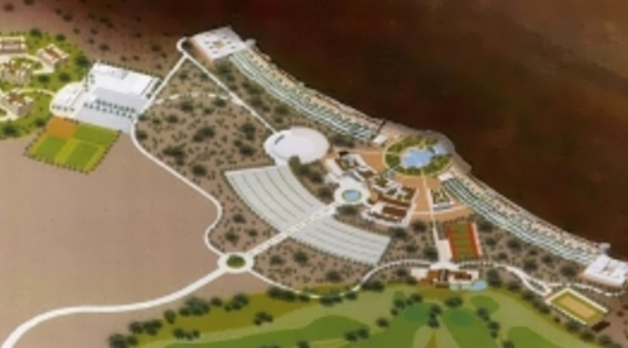

# **TABLE OF CONTENTS**

**TABLE OF CONTENTS** 2

**1.** **CHAPTER ONE: INTRODUCTION** 4

**1.1.** **Background** 4

**1.2.** **Scope of the Plan** 4

**1.3.** **Location and Size** 4

**1.4.** **Administrative and political units in the municipality** 5

**1.5.** **Methodology** 5

**1.6.** **Constitutional, Policy and Legal Framework** 5

**2.** **CHAPTER TWO: SITUATION ANALYSIS.** 6

**2.1.** **Base map** 6

**2.2. Physiographic characteristics** 6

**1.1.** **Population and demography** 8

**1.1.1.** **Population** 8

**1.1.2.** **Social Analysis** 9

**1.2.** **Land** 9

**1.2.1.** **Land tenure and ownership** 9

**1.2.2.** **Land use** 9

**1.3.** **Environment and Natural Resources** 10

**1.3.1.** **Environment.** 10

**1.3.2.** **Environmental issues in Urban Context** 11

**1.3.3.** **National and County Legislation Polices on Environmental and Natural Resource Management** 11

**1.3.4.** **Climate Change and Disaster Management.** 13

**1.3.5.** **Natural Resources Management** 14

**1.4.** **Human Settlements and Urbanization** 15

**1.4.1.** **Patterns and Trends of Human Settlements** 15

**1.4.2.** **Urbanization trend in Isiolo County** 16

**1.4.3.** **Urbanization and County Socio-Economic Development** 16

**1.4.4.** **Urban development challenges** 17

**1.4.5.** **Housing** 17

**1.5.** **Transport, Infrastructure and Services** 19

**1.5.1.** **Transport Network and Distribution** 20

**1.5.2.** **Information and Communication Technology** 21

**1.5.3.** **Energy** 21

**1.5.4.** **Water** 23

**1.5.5.** **Waste Management and Sanitation** 24

**1.5.6.** **Social Infrastructure** 25

**1.6.** **Economic Development** 26

**1.6.1.** **Agriculture** 26

**1.6.2.** **Mining** 27

**1.6.3.** **Tourism and Hospitality** 27

**1.6.4.** **Trade Industries and commerce** 28

**1.6.5.** **Employment** 29

**2.** **CHAPTER THREE: URBAN DEVELOPMENT STRATEGIES** 30

**2.1.** **Overview** 30

**2.2.** **Policies, Strategies and Actions** 30

**2.2.1.** **Social Development Strategy** 30

**2.2.2.** **Environment and Natural Resources development strategy** 31

**2.2.3.** **Sanitation and Waste management** 32

**2.2.4.** **Economic Development** 33

**2.2.5.** **Land and urban Planning** 35

**2.2.6.** **Urban and Human Settlements Infrastructure** 36

**2.2.7.** **Transport, Communication and Infrastructure** 38

**2.2.8.** **Urban Governance** 39

**3.** **CHAPTER FOUR: SPATIAL DEVELOPMENT FRAMEWORK AND ACTION PLANS** 41

**4.** **CHAPTER FIVE: MONITORING AND EVALUATION** 42

# **LIST OF TABLES AND FIGURES**

Figure 1Isiolo Municipal Soil Map 8

Figure 2Isiolo Municipality Contour Map 8

Figure 3: Isiolo Municipality Population Density 9

Figure 4; Isiolo Municipality Zoning 11

Figure 5: Percentage Distribution of Households by Floor Material in Isiolo County 19

Figure 6: Percentage Distribution of Household by Roof Material in Isiolo County 19

Figure 7: Percentage Distribution of Household by Wall Material in Isiolo County 20

Figure 8: Isiolo Municipality Road Network 21

Figure 9: Percentage Distribution of households by Source of cooking Fuel in Isiolo County 22

Figure 10: Percentage distribution of Households by Source of lighting Fuel in Isiolo County 23

Figure 11 Water facilities in Isiolo Town 24

Figure 12: Isiolo County Mineral Map 28

# **CHAPTER ONE: INTRODUCTION**

## **Background**

The urban population in the county is about 42% of the 2009 census total county population of 143, 294 (CIDP 2013-2018). This translates to about 60,183 people leaving in urban areas. The county’s population is projected to reach 191,627 by 2017. Assuming the percentage urban population remains the same as of the 2013-17 CIDP, then 80,483 will be leaving in urban centers by 2017. The county’s spatial economy is defined by the single dominant urban center of Isiolo Town and a few rural service canters scattered along major transport arteries. The main transport routes are the A2 highway that passes through Isiolo Town and the B9 from Isiolo to Modogashe on which are Garba Tulla, Modogashe and Kulamawe centers. Others are Merti and Kinna urban centers located on E822 and E817 roads respectively. These two roads have been reclassified to class C recently. Other mainly administrative centers have developed out of localized settlements around water points and security posts. These smaller centers include Oldonyiro and Ngaremara. The urban areas (growth and service centers) including Isiolo, Merti, Garba Tulla, Kinna and Modogashe portray a pattern of urban land use dominated by residential housing (about 70%). Isiolo Town is the dominant urban centre and also the county headquarters. It covers approximately 65 km2. The main factor behind the growth of Isiolo Town is its strategic location on the transit corridor A2 road linking Nairobi to Addis Ababa in Ethiopia. Isiolo town started as a base for King’s African Riffle. The colonial government declared the Northern Frontier district in 1909 covering the whole county and other northern parts of Kenya with its headquarters in Meru. However, in 1928, the colonial government recognized the strategic position of Isiolo as a gateway to the North, Somali and Abyssinia and decided to move the district headquarters to Isiolo.

## **Scope of the Plan**

The objective of Isiolo Urban Integrated Development Plan is to provide an integrated urban development framework for coordinated municipal development. The Plan seeks to integrate all services in the municipality and align them to the County integrated development plan 2018-2022 and the Vision 2030. The Constitution of Kenya 2010, County Government Act 2012 and the Urban Areas and Cities Act 2011. Provide guidance on the importance of developing Urban Integrated development Plans. The urban Areas and Cities Act 2011 provides that every city and municipality established under the Act shall operate within the framework of integrated development planning. The Act gives effect to the development of urban areas and cities as required by this Act and any other written law. The objective of the five year Integrated development Plan is to provide a framework under which urban development projects in Isiolo will be conceptualised to improve service delivery on an inclusive basis and in ways that enhance Economic growth and development in the County.

## **Location and Size**

Isiolo Municipality is the dominant urban centre and also the county headquarters. It covers approximately 65 km2. Isiolo Town serves as the commercial and administrative capital of the county. It is strategically location on the tA2 road linking Nairobi to Addis Ababa. It provides all commercial and administrative services. Isiolo is located between Longitudes 36o 50‟ and 39o 50‟ east and latitude 0o 05‟ south and 20 north. Isiolo town lies 285 kilometres north of Nairobi, the capital city of Kenya by road.

## **Administrative and political units in the municipality**

The Municipality has one constituencies that is Isiolo North and comprises of three wards namely Wabera, Bulapesa and Burati. The town is cosmopolitan with the Somalis, Boranas, and the Merus forming the largest chunk of the residents. Although the town is comparatively small in size, it is significant for hosting travelers as they commute between the towns of Marsabit and Moyale

## **Methodology**

Different approaches were applied during the planning stages in order to ensure that there was participation of diverse groups in the development of the integrated urban development plan. Participants reached through meetings, individual interviews and Focus group discussion were drawn from different sectors including Municipal Board members, Sub County Directors, religious representatives, community groups, market traders, education sector, agriculture sector, public health, women groups, professional and academic groups and the private sector. The focus of public participation was to assess the current situation and build evidence for the development of programmes priorities that meet the needs of the people. This was achieved through discussions with various groups. Through public participation there were suggested proposals on priority programmes and projects.

## **Constitutional, Policy and Legal Framework**

Article 184 of the Constitution of Kenya 2010 provides for the governance and management of urban areas and cities in the country. This is effected through the Urban Areas and Cities Act, 2011 which clearly defines various classes of urban areas and the nature and function of urban management structures. Other supportive legislations and policies include the County Government Act 2012 and the Physical Planning Act cap 286 of Kenya which is under review. The County Government has developed and approved the charter which established Isiolo town as a municipality. The County government has also established the Isiolo Municipal Management Board and appointed the municipal manager for the municipality. The National Urban Development Policy, which is considered as an “umbrella policy”, aims at strengthening development planning, urban governance, and management, and promotion of urban investment and delivery of social and physical infrastructure in urban areas throughout the country. The Urban Areas and Cities Act 2011 states the definition and management of urban areas and cities. The Physical Planning Act 1996 defines the urban development management. The National Land Commission Act 2012 describes the functions of the National Land Commission and the objects and principles of devolved government in land management and administration.

# **CHAPTER TWO: SITUATION ANALYSIS.**

## **Base map**

## **2.2. Physiographic characteristics**

Isiolo Municipality is endowed with great potential of the physical and biological environment as natural

Capital for growth and development. These factors include: Topography, Geology, Soils, agro ecological,

Climate (rainfall and temperature), water resources, and landscapes.

**Soils**

The Municipality is mainly very clayey and sandy as indicated in the figure below. The figure shows that type of soil map in the areas covered within the Municipality.

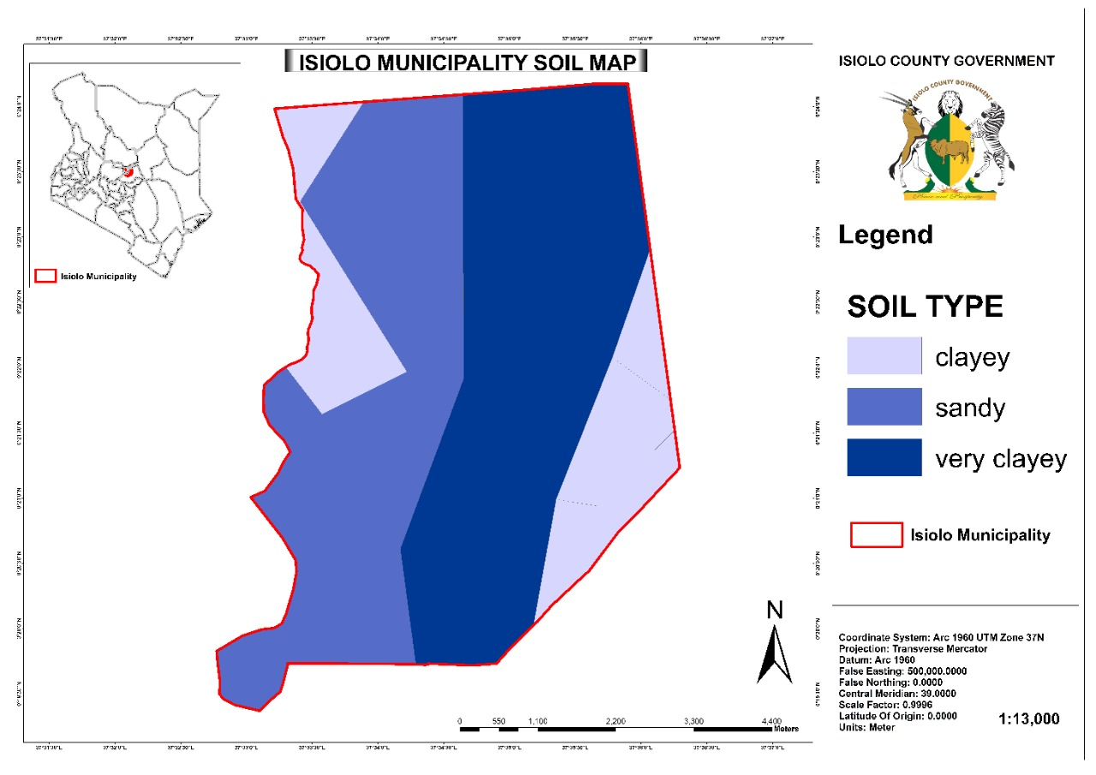

**Figure 1Isiolo Municipal Soil Map**

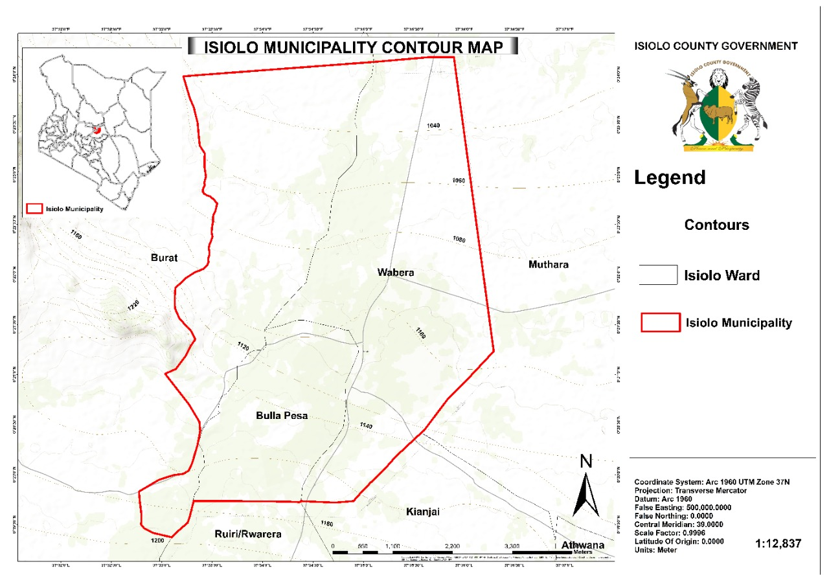

**Figure 2Isiolo Municipality Contour Map**

## **Population and demography**

### **Population**

Isiolo Municipality is established as per the Urban Areas and Cities Act of 2011 (amended 2019). The Municipality has a total population of 58,927 as per 2009 census report distributed as follows: Wabera ward with a population of 17,431; Bulla Pesa ward 22,722 and Burat ward 18,774. The 2009 census results also showed that the municipality had a population density of 24 persons per square Kilometer. The population of the municipality is projected to grow to 88,427 by 2022. The population density is projected to be at 27 persons per Km2 in the year 2022[1].

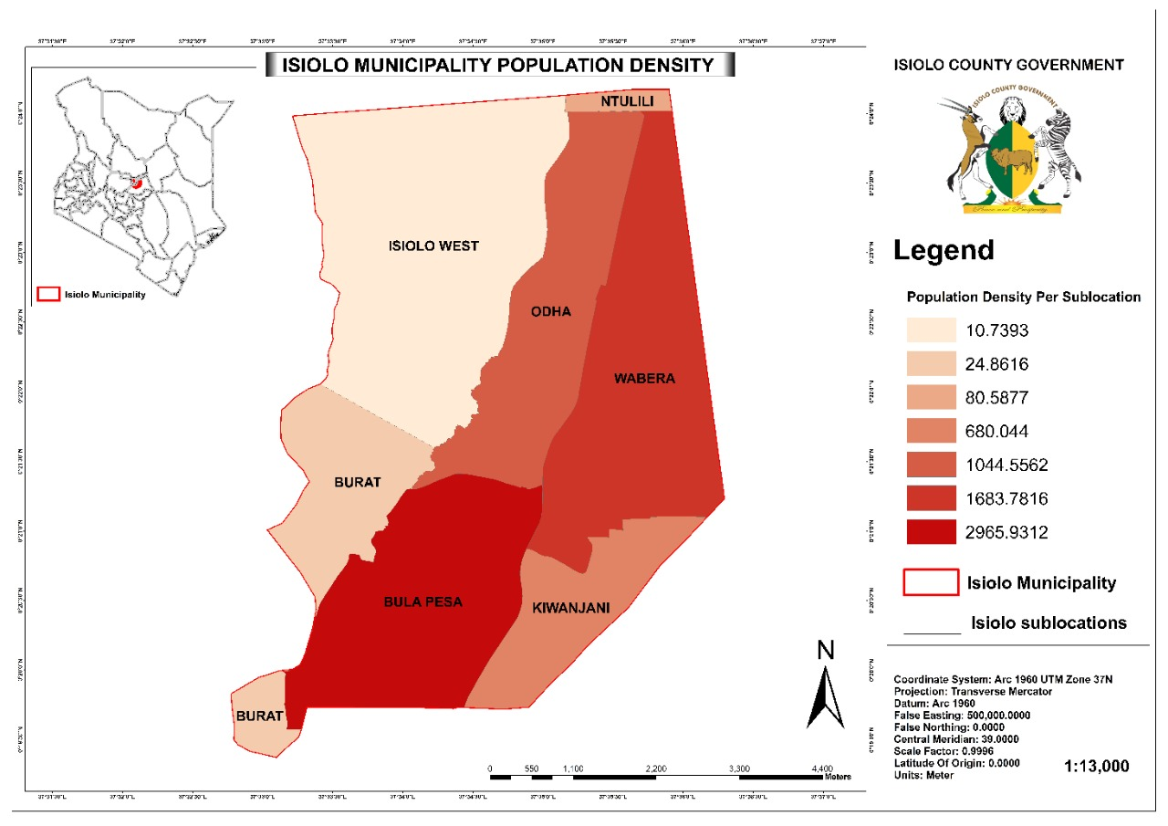

**Figure 3: Isiolo Municipality Population Density**

**Demography**

### **Social Analysis**

The Kenya Integrated Household Budget Survey 2005-2006 estimated the poverty line at KSh2, 913 per person per month for urban households. According to the survey, the share of individuals below the poverty line was the highest at 29.8% in Makadara Division and lowest at 15.3% in Wetlands Division. As a very broad trend, a larger number of relatively high income households are found in the west of the Central Business District (CBD) than in the east, although there are a number of low income informal settlement areas in the western areas such Kibera and Kawangware.

## **Land**

### **Land tenure and ownership**

More than 80% of the land is communally owned and is under the trust ship of the county government. Public land constitutes 10 percent of total land and includes land for schools, administration, health facilities and game reserves. The remaining less than 10% of the land is under private ownership and was alienated for private investment in housing, industrial and commercial purposes[2]. Over 80 percent of the land cannot support crop farming and is used as grazing land by the pastoralists. There are a few cases of landlessness mainly in the urban centres where poor immigrants do not own land or plots. Isiolo municipality is characterized by an annual rainfall of between 400 – 650 mm. The relatively high rainfall is due to the influence of Mount Kenya and Nyambene Hills in the neighbouring Meru County. This semi-arid zone covers mainly the parts of Wabera and Bulla Pesa Ward but also extends to parts of Burat Ward. The vegetation in this zone is mainly thorny bush with short grass[3].

### **Land use**

Land use planning in Isiolo Municipality provides for mixed land use. Isiolo municipality was identified as a priority urban centre in Isiolo County for the titling program. The Ministry of Lands and Physical Planning and the County Government of Isiolo intends to undertake a comprehensive re-planning for Isiolo Municipality. Isiolo town has a development plan ISL/117/2006/001 prepared and approved in the year 2006/2007. There exist discrepancies between the current development on the ground and the proposals of the approved Development Plan ISL/117/2006/001 for Isiolo Township. This revision is necessitated by the rapid land use changes in the Municipality and the need to have an integrated plan that captures emerging land use needs adopting world best practices.

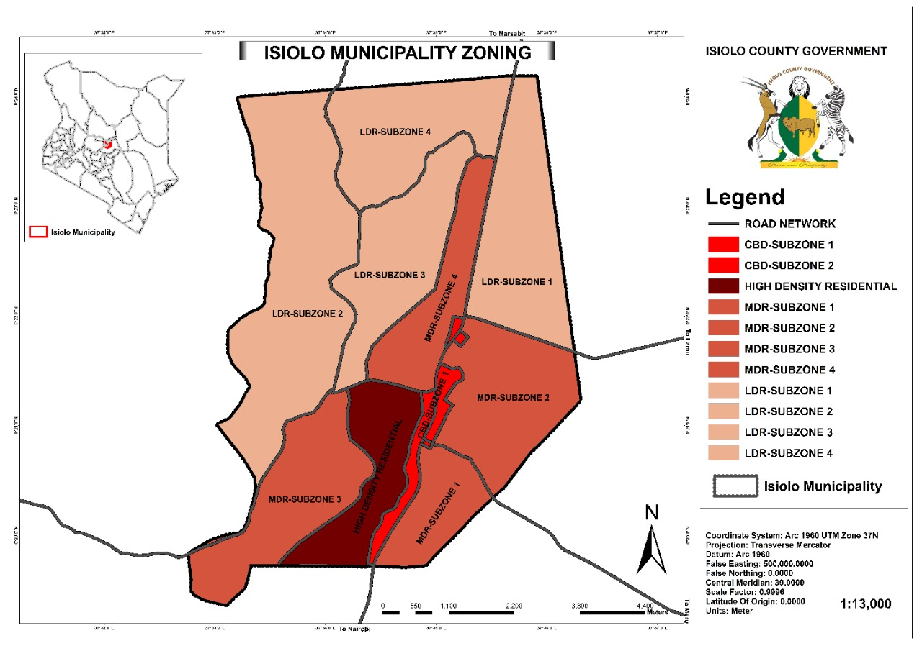

**Figure 4; Isiolo Municipality Zoning**

## **Environment and Natural Resources**

### **Environment.**

Environmental issues were first addressed worldwide in relation to urban development at the United Nations Conference on Human Environment in Stockholm in 1972 where it was agreed that there is a need for a common concern for the preservation and enhancement of the human environment[4]. The world is becoming increasingly urbanized, and with this accelerating process comes a host of challenges. Urban areas now contain more than 50 per cent of the world’s population, occupy just two per cent of the world’s terrestrial surface, and consume up to 75 per cent of natural resources. In Isiolo County, the livelihoods of most residents depend natural resources. The county is hot and dry in most months of the year hence the vegetation cover is very low and scattered. Charcoal burning, sand harvesting, overgrazing and overstocking in most parts of the county has been rapidly depleting the vegetation cover leaving land exposed to soil erosion. Much of the soil erosion is also caused by strong winds which lead to massive environmental destruction. Environmental degradation has led to decreased vegetation cover; increase of environment-related diseases such as kalaazar, eyes and respiratory problems. During the windy season, visibility becomes very poor due to huge amount of dust. This has induced increase in both air and water borne diseases in the county. Agricultural and livestock productivity is worsened by limited, unreliable and poorly distributed rainfall pattern. In recent years the rains have become erratic and unpredictable hence making it difficult to plan on farming.

### **Environmental issues in Urban Context**

NEMA Environmental and sustainability plan requires ministries and departments to integrate environmental considerations in their operations to fulfil the requirement of a clean, healthy and sustainable environment for all as per article 42 of the Constitution and EMCA Cap 387. This requires the adoption and maintenance of good practices that contribute to the quality of environment on a long term basis. The following factors are environmental factors that affect environment issues and urban area and which also largely apply to the Isiolo Municipality.

***Environmental Hazards*** Poor quality and overcrowded housing, inadequate water supply, sanitation and solid waste disposal are all potential environmental hazards which can have a negative impact on the lives of the urban poor. Environmental pollution may also be exacerbated by industrial waste disposal.

***Social Fragmentation*** There is greater social and economic heterogeneity in urban areas, which can lead to a weakening of community and inter-household trust and collaboration. Concerns for personal safety are far more important in the urban context arising from this weakening of social cohesion

***Livelihoods*** - There is more reliance on income earning opportunities, less access to natural resources and reducing poverty through agricultural production and trade. The key role that housing has as an economic resource.

***Environmental Health*** - There are higher levels of health risk if provision for wholesome water and good waste management is absence. But there is also the possibility, through economies of scale, to improve environmental health through the provision of good infrastructure and emergency services. Occupational health and safety risks are often higher especially where regulations on pollution control and safety do not exist or are not enforced.

***Higher Living Costs*** - Greater commercialization of housing and land (commoditization) and the cost of many basics are higher. This increases the importance of ‘expenditure reducing’ components of poverty reduction projects in urban areas. Public/community action may result for example in cheaper water (for those reliant on water vendors) or cheaper sanitation (for those who only have access to pay as you use toilets.

***Social Aspects*** - There is more social and cultural diversity which can weaken social capital. Also, there is more constant change in population which can weaken cooperative action.

***Governance -*** There is greater dependence on government for protection from health hazards through the provision of infrastructure, waste management and pollution control. Also there is greater potential impact of ‘bad’ government for example: large scale evictions, harassment of hawkers and political rights abuses.

### **National and County Legislation Polices on Environmental and Natural Resource Management**

The promulgation of The Constitution of Kenya 2010 and other new developments like climate change marked an important chapter in Kenya’s environmental policy development. Hailed as a ‘Green’ Constitution, it embodies elaborate provisions with considerable implications for sustainable development. These range from environmental principles and implications of Multilateral Environmental Agreements (MEAs) to the right to a clean and healthy environment as enshrined in the Bill of Rights. Chapter V is entirely dedicated to land and environment. It also embodies a host of social and economic rights which are of environmental character such as the right to water, food and shelter, among others. The Constitution devolved all planning activities to the County with environmental planning being a devolved function. The Constitution has similarly elevated the right to a clean and healthy environment to a human right.

It is the responsibility of the government through the ministry responsible for environmental issues to ensure that policies are reviewed and formulated to meet the aspirations of the Constitution and emerging issues in the management of the environment for prosperity. Such a policy should aim at providing a holistic framework to guide the management NATIONAL ENVIRONMENT POLICY, 2013 of the environment and natural resources in Kenya. It should further ensure that environment is integrated in all government policies in order to facilitate and realise sustainable development at all levels. This would help promote green economy, enhance social inclusion, improve human welfare and create opportunities for employment and maintenance of a healthy ecosystem. The following environmental policies will be instrumental in providing policy direction on promoting integration of environmental plans in the urban integrated development plan for the Isiolo County.

#### **Environmental Management and Coordination Act, 1999**

An ACT of Parliament to provide for the establishment of an appropriate legal and institutional framework for the management of the environment and for the matters connected therewith and incidental thereto. The act is supported by the following regulations.

1. **Noise Regulations, 2009**

These Regulations prohibit a production of any loud, unreasonable, unnecessary or unusual noise which annoys, disturbs, injures or endangers the comfort, repose, health or safety of others and the environment.

1. **Wetland Regulations, 2009**

These regulations outline management of wetlands, wetland resources, river banks, lake shores and sea shores. Specific sections have requirements that apply to wetlands in Kenya either in private or public land. The regulations empower the District Environment Committee to co-ordinate, monitor and advise on all aspects of wetland resource management within the district.

1. **Water Quality Regulations**

This includes the following: Protection of sources of water for domestic use; Water for industrial use and effluent discharge; Water for agricultural use. These Regulations outline: Quality standards for sources of domestic water; Quality monitoring for sources of domestic water; Standards for effluent discharge into the environment; Monitoring guide for discharge into the environment; Standards for effluent discharge into public sewers

1. **Waste Management Regulations**

These Regulations apply to all categories of waste. These include: Industrial wastes; Hazardous and toxic wastes; Pesticides and toxic substances; Biomedical wastes; Radio-active substances. These regulations outline requirements for handling, storing, transporting, and treatment/ disposal of all waste categories. Disposal of waste by NEMA licensed company.

1. **EIA Regulations**

No licensing authority under any law in force in Kenya shall issue a license for any project for which an environmental impact assessment is required under the Act unless the applicant produces to the licensing authority a license of environmental impact assessment issued by the Authority under these Regulations. Regulation 4 (3) states that “No licensing authority under any law in force in Kenya shall issue a trading, commercial or development permit or license for any micro project activity likely to have cumulative significant negative environmental impact before it ensures that a strategic environmental plan encompassing mitigation measures and approved by the Authority is in place”

1. **Controlled substances**

These are basically ozone depleting gases. One needs a license to: Produce Controlled Substances. Import Controlled Substances. Transport Controlled Substances through Kenya. Export Controlled Substances.

1. **Biological diversity resources, access to genetic resources and benefit sharing) regulations, 2006**

Environmental Impact Assessment Licences to: Engage in activities with an adverse impact on any ecosystem; lead to the introduction of any exotic species; lead to unsustainable use of natural resources, Any person who intends to access genetic resources in Kenya needs an Access permit for genetic resources in Kenya with a certificate from National Council for Science and Technology

#### **The National Environmental Policy, 2013**

This Policy proposes a broad range of measures and actions responding to key environmental issues and challenges. It seeks to provide the framework for an integrated approach to planning and sustainable management of natural resources in the various policy measures not only to mainstream sound environmental management practices in all sectors of society throughout the country but also recommends strong institutional and governance measures to support the achievement of the desired objectives and goal.

### **Climate Change and Disaster Management.**

Climate change is becoming one of the most serious challenges to Kenya’s achievement of its development goals as described under Vision 2030. Kenya is already highly susceptible to climate-related hazards, and in many areas extreme events and variability of weather are now the norm; rainfall is irregular and unpredictable; while droughts have become more frequent during the long rainy season and severe floods during the short rains. The arid and semi-arid areas are particularly hard hit by these climate hazards, thereby putting the lives and livelihoods of millions of households at risk. In 2010, Kenya developed a National Climate Change Response Strategy (NCCRS) which recognized the importance of climate change impacts on the country’s development. This was followed by the National Climate Change Action Plan (NCCAP) in 2012 which provided a means for implementation of the NCCRS, highlighting a number of agricultural adaptation priorities. The focus of these initiatives has been at the national level, and there is need to mainstream climate change into county level policies, programmes, and development plans; therefore ensuring locally relevant, integrated adaptation responses with active involvement of local stakeholders[5].

The county is hot and dry in most months of the year hence the vegetation cover is very low and scattered. Charcoal burning, sand harvesting, overgrazing and overstocking in most parts of the county has been rapidly depleting the vegetation cover leaving land exposed to soil erosion. Much of the soil erosion is also caused by strong winds which lead to massive environmental destruction. Environmental degradation has led to decreased vegetation cover; increase of environment-related diseases such as kalaazar, eyes and respiratory problems. During the windy season, visibility becomes very poor due to huge amount of dust. This has induced increase in both air and water borne diseases in the county. Agricultural and livestock productivity is worsened by limited, unreliable and poorly distributed rainfall pattern. In recent years the rains have become erratic and unpredictable hence making it difficult to plan on farming[6]. The County government seeks opportunities to support climate-smart economic pathways for improved livelihoods and resilience, supporting initiatives that improve access to renewable energy for off-grid households, targeting rural and female-headed households that depend primarily on biomass for energy needs. Strengthening disaster risk reduction and communities’ resilience: While Kenya has undertaken structural and policy frameworks to address and reduce the impact of disasters on communities especially in the Arid and Semi-Arid Lands (ASALs) remain highly vulnerable to natural and human-made calamities such as drought, floods and conflict.

The County government has improved its capacity to address climate change impacts through development of: Draft Disaster Risk Management Policy; Isiolo River basin integrated Flood Management Plan; Samburu- Isiolo Conservation area management Plan; Isiolo County climate change fund Act 2018; The object of this Act is to create a fund in the County for the purpose of facilitating establishment of a mechanism to finance climate change activities, programs and projects in the County. Further, resource allocation for climate change action was ensured through inclusion of dedicated budget lines to climate in the County Integrated development Plan 2018-2022. The County has also developed the County Hazard Atlas. The purpose of the atlas is to improve efforts to reduce disaster risks and respond effectively when disaster strikes. The Atlas helps guide the design and implementation of programmes, and integrates measures that reduce disaster risks in policies, strategies and plans. The most common hazards in Isiolo County include: droughts, floods, conflict (human wildlife conflict), Livestock diseases, crop pets, soil erosion and environmental degradation. This hazards lead to loss of life for both human and livestock due to conflict and displacement of communities.

### **Natural Resources Management**

The Kenyan economy is dependent on its natural resources. However, poor natural resource management, unsettled resource governance structures and rapid population growth, have put great strains on these resources. Present critical issues include land degradation, land-use conflicts, lost opportunities for sustainable natural resource utilization, depletion of water catchment areas, and a serious loss of biodiversity. The effects have been particularly adverse in the arid and semi-arid regions of the country, where the environment is threatened by increasingly unsustainable use of the areas with the highest potential for production during the dry season and which are seeing expanding agriculture, fuel-wood collection, charcoal burning, deforestation, and localized overgrazing – all exacerbated by the impacts of climate change. The arid and semi-arid lands, home to over 14 million people, cover about 89% of Kenya. Over 70% of the population in these areas live below the poverty line. Despite the high incidence of poverty, there is a vast base of natural resources in the ASALs, much of which remains underutilized. The ASAL areas are increasingly being recognized as the ‘new frontier’, because of their potential to transform the country’s economic development and realization of Vision 2030. Government strategies recognize that, with the right political will and practical interventions, these resources can be better managed and the current poverty and low human development indicators can be reversed[7].

Isiolo County, like all other counties in northern Kenya, is arid. Most of its residents are pastoralists who move from one place to another in search of water and pasture for their livestock. The scarcity of these resources has often resulted in violent conflict as these pastoralist communities struggle to acquire and control the little that is available. This conflict and violence mainly takes the form of cattle rustling, interethnic violence, and displacement. The environment has also changed drastically due to stress on existing resources, resulting in an increase in droughts, famines, and other natural catastrophes. The pastoralists are also facing myriad new land related conflicts, some of which are related to administrative and electoral boundaries. The recurrent violent conflicts in Isiolo County have been aggravated by the presence of small arms and light weapons; tensions with agricultural communities, especially those at the boundary with Meru County; and human–wildlife conflicts that are intensified by competing uses of land for commercial ranching and wildlife conservation, amongst others[8].

The county government of Isiolo has an established Bill to protect the natural resources of the County. The Isiolo County Customary Natural Resource Management Bill, 2016 provides for customary management of natural resources in Isiolo County. The Bill further provides for recognition, and use of indigenous knowledge systems in management of natural resources; Provide for establishment of a Council of Elders to coordinate the management of water and pastures within Isiolo County; provide for establishment of a Council of Elders to coordinate the management of water and pastures within Isiolo County; to ensure that all members of the community have access to water and forest resources available within the county; and to provide for penalties for the commission of any prohibited activity that may negatively affect the sustainability of the resources is halted. The County has also developed a Resource Atlas. Among the identified interventions the Resource Atlas is to improve pasture and water management, enhance livestock disease control initiatives, develop markets and market infrastructure, construct modern abattoirs and create disease free zones. The County Resource Atlas is intended to guide planning and implementation of these interventions.

## **Human Settlements and Urbanization**

Human settlements are concentrations of activities and people, whether they are the smallest village or the largest metropolis. To be productive, economic growth requires some degree of concentration of activities and people to secure some degree of economic and technical efficiency. Human settlements therefore play an essential role as agents of economic growth by providing favorable locations for productive investment. Consequently, the development of human settlements is a critical process in the transformation of traditional/rural societies into the modern/urban state. It is worth noting that it is in urban areas that most activities and processes which are usually associated with modern economic and social progress most immediately present themselves, but it is also here that the problems of degradation of the environment and human qualities of life are most acute[9]. The rising rate of urbanization has resulted in an increased population within the urban areas and hence putting pressure on existing infrastructure. Kenya has a high youthful population amidst increased unemployment levels and an increasing aging population in urban areas. This calls for provision of necessary services and facilities to support them and the need to engage them gainfully.

### **Patterns and Trends of Human Settlements**

Human Settlement Patterns in Isiolo Municipality can be classified as:

1. Nucleated – Urban settlements come to existence because of rural-urban and inter-urban migration.
2. Dispersed and clustered – this refer to the traditional rural settlements and those grouped homesteads arising from the nomadic nature of the various pastoral communities. Clustered settlements are those that are concentrated at some places and they are brought together by culture among other reasons. For example, most communities in Isiolo County are pastoralists and live in Manyattas
3. Linear – these are settlements along transport corridors. Isiolo Town is considered a gateway town along the Northern Corridor.

### **Urbanization trend in Isiolo County**

The urban population in the county is about 42% of the 2009 census total county population of 143, 294 (CIDP 2013-2018). This translates to about 60,183 people leaving in urban areas. The county’s population is projected to reach 191,627 by 2017. Assuming the percentage urban population remains the same as of the 2013-17 CIDP, then 80,483 will be leaving in urban centers by 2017. The county’s spatial economy is defined by the single dominant urban center of Isiolo Town and a few rural service centers scattered along major transport arteries.

The main transport routes are the A2 highway that passes through Isiolo Town and the B9 from Isiolo to Modogashe on which are Garba Tulla, Modogashe and Kulamawe centers. Others are Merti and Kinna urban centers located on E822 and E817 roads respectively. These two roads have been reclassified to class C recently. Other mainly administrative centers have developed out of localized settlements around water points and security posts. These smaller centers include Oldonyiro and Ngaremara. The urban areas (growth and service centers) including Isiolo, Merti, Garba Tulla, Kinna and Modogashe portray a pattern of urban land use dominated by residential housing (about 70%). Isiolo Town is the dominant urban centres and also the county headquarters. It covers approximately 65 km2. The main factor behind the growth of Isiolo Town is its strategic location on the transit corridor A2 road linking Nairobi to Addis Ababa in Ethiopia. Isiolo town started as a base for King’s African Riffle.

The colonial government declared the Northern Frontier district in 1909 covering the whole county and other northern parts of Kenya with its headquarters in Meru. However, in 1928, the colonial government recognized the strategic position of Isiolo as a gateway to the North, Somali and Abyssinia and decided to move the district headquarters to Isiolo

### **Urbanization and County Socio-Economic Development**

Isiolo Town serves as the commercial and administrative capital of the county. It is strategically location on the tA2 road linking Nairobi to Addis Ababa. It provides all commercial and administrative services. It is also the dominant provider of financial services in the county with presence of most major banks and some micro finance institutions; and provides higher level education and training services. The next level of urban centres are mainly rural service centres providing lower level administrative services (sub-county level), limited commercial services i.e. few basic good stores, shops, few hotels and lodges and county level educational institutions. They do not have major banks but agency banking operate in them. These include Garba Tulla, Merti and Kina. All other centres have only few shops providing minimum basic goods and basic education facilities. The dominant pastoral economy in the county dictates the location of these centres far apart. Most people therefore travel long distances to Isiolo town to access critical services especially financial and specific educational services. With the low road network and poor condition of roads, it is a big challenge for people to access services available in these centres, particularly in the county headquarter.

Isiolo town has fairly good urban infrastructure. The town has some few paved roads, modern street light and water and sewer system. It has also invested in improving urban safety through not only street lighting but also high mast flood lighting in its sub-urban estates. The town also boasts telecommunication connectivity, modern livestock market, a town park, drainage system and is connected to national electricity grid. While these services have improved livability of the town, they are inadequate for the fast growing town. There is therefore need for the town to invest more in them. Among the most challenging service to provide in the town is solid waste management. Apart from Isiolo Town, other centers seldom have any urban service to talk of. All urban centers in the county need clear proper planning and clear boundary marking. The most urgent for Isiolo town is to control urban sprawl that is significantly increasing due to population increase triggered by in-migration by many people hoping to partake in the benefits of LAPSSET projects to be implemented in the county

### **Urban development challenges**

One of the critical urban development challenges in the county is lack of proper planning. Almost all urban centers except Isiolo have no spatial plans or have very old ones that need urgent updating. Merti for example has an old plan dating back to 1978, while Modogashe has one done in 1974. Garbatulla was lastly planned in 2013 but the plan is not approved. Isiolo Town itself needs reviewing of its plan since it was last done in 2006. Due to lack of planning, most of urban centers have no spaces identified for development of infrastructure and service. The main rural service centers of Merti, Garba Tulla and Kina are deficient in these. Garba Tualla, Kina and Modogashe are going to be transformed into growth centers due to their strategic location on B9 linking Isiolo to the whole of North Eastern which is being upgraded to bitumen standards by the national government to provide regional link to the LPASSET corridor.

Lack of sufficient funding particularly through the county budget is also a serious problem. Due to lack of sufficient funding, poor infrastructure development is a feature of urban centers in the county. Isiolo town for example has serious problem of solid waste management, storm water drainage, fire and disaster management. Because of lack of these and other infrastructure, urban centers in the county can hardly play their role of drivers of economic transformation and social cultural integration.

### **Housing**

Shelter is a basic human need and Article 43 1(b) of the Constitution of Kenya 2010 emphasizes the right of every person to accessible and adequate housing, and to reasonable standards of sanitation. However, housing sub-sector is characterized by inadequacy of affordable and decent housing; extensive and inappropriate dwelling units including slums and informal settlements. This is due to under-investment in low-cost housing, outdated legal and regulatory framework, uncoordinated policy implementation, low private sector participation, inequitable and skewed access and ownership to land in urban areas, slow absorption of modern housing technologies and inadequate financing to buyers and developers

Housing plays an important role in employment and wealth creation. Adequate housing as a social good also contributes directly to improved health and productivity. There is therefore need for informed interventions by Government and stakeholders in facilitating the production of decent and affordable housing for Kenyans. This is only possible if such interventions are guided by accurate and reliable data on housing and related facilities. The development of housing has not kept pace with changes in household formation

The housing aspect in Isiolo which is the major urban center has been driven mainly by private investment. Public investment has been restricted to interventions by the National government. Housing Corporation that had a few estates of low cost housing units sold to local people. This has however been not sustained for the last two decades. Housing types and stock is of low quality due to poor affordability. There are a few units of houses constructed by the NHC under the civil service housing scheme adding to the overall housing stock. There is opportunity for public private partnerships for investment in housing sector in the county.

**Flooring**

**Figure 5: Percentage Distribution of Households by Floor Material in Isiolo County**



29.0

0

.5

.4

0

69.9

0

.2

-

10.0

20.0

30.0

40.0

50.0

60.0

70.0

80.0

Cement

Tiles

Wood

Earth

Other

**P**

**e**

**r**

**c**

**e**

**n**

**t**

**age**

**Figure 9.6: Percentage Distribution of Households by Floor Material in Isiolo County**

*Source: Exploring Kenya’s Inequality; Pulling Apart or Pulling Together Isiolo County Report 2013*

In Isiolo County, 29% of residents have homes with cement floors, while 70% have earth floors. Less than 1% has wood and just 1% has tile floors. Isiolo North constituency has the highest share of cement floors at 38%. This is six times Isiolo South constituency, which has the lowest share of cement floors. Isiolo North constituency is 9 percentage points above the county average. Bula Pesa ward has the highest share of cement floors at 74%. This is 73 percentage points above Chari ward, which has the lowest share of cement floors. Bula Pesa ward is 45 percentage points above the county average.

**Roofing**

**Figure 6: Percentage Distribution of Household by Roof Material in Isiolo County**

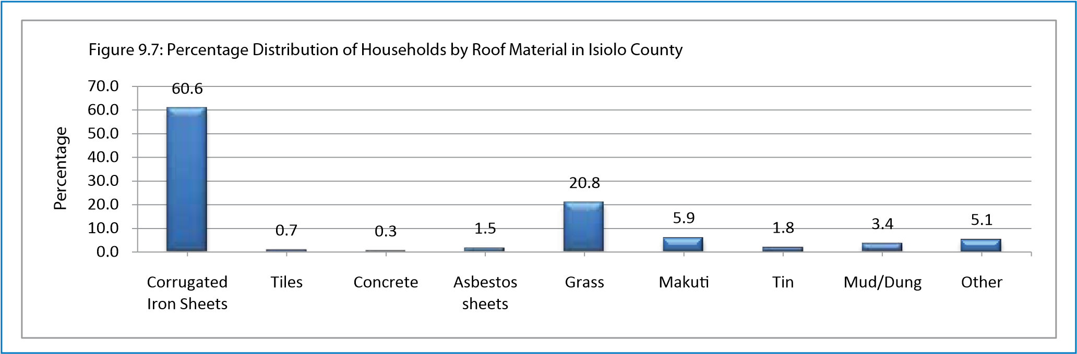

*Source: Exploring Kenya’s Inequality; Pulling Apart or Pulling Together Isiolo County Report 2013*

In Isiolo County, less than 1% of residents have homes with concrete roofs, while 61% has corrugated iron roofs. Grass and makuti roofs cover 27% of homes, and 3% have mud/dung roofs. Isiolo North constituency has the highest share of corrugated iron sheet roofs at 66%. This is 20 percentage points above Isiolo South constituency, which has the lowest share of corrugated iron sheet roofs. Isiolo North is 5 percentage points above the county average. Bula Pesa ward has the highest share of corrugated iron sheet roofs at 96%. This is almost 11 times Oldonyiro ward, which has the lowest share of corrugated iron sheet roofs. Bula Pesa ward is 35 percentage points above the county average. Isiolo South constituency has the highest share of grass/makuti roofs at 52%. That is three times Isiolo North constituency, which has the lowest share of grass/makuti roofs. Isiolo South constituency is 25 percentage points above the county average. Garbatulla ward has the highest share of grass/makuti roofs at 63%. This is 63 percentage points above Bula Pesa ward, which has the lowest share. Garbatulla ward is 36 percentage points above the county average.

**Walls**

**Figure 7: Percentage Distribution of Household by Wall Material in Isiolo County**

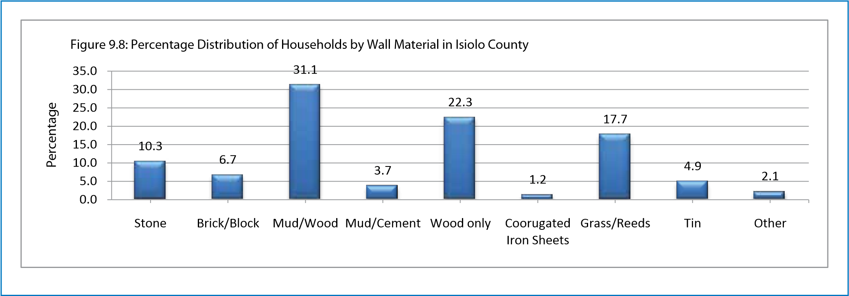

*Source: Exploring Kenya’s Inequality; Pulling Apart or Pulling Together Isiolo County Report 2013*

In Isiolo County, 17% of homes have either brick or stone walls, 35% have mud/wood or mud/cement walls, 22% have wood walls and 1% has corrugated iron walls. Another 18% have grass/thatched walls, while 7% have tin or other walls. Isiolo North constituency has the highest share of brick/stone walls at 23%. That is seven times Isiolo South constituency, which has the lowest share of brick/stone walls. Isiolo North constituency is 6 percentage points above the county average. Bula Pesa ward has the highest share of brick/stone walls at 44%. This is 43 percentage points above Chari ward, which has the lowest share of brick/stone walls. Bula Pesa ward is 27 percentage points above the county average. Isiolo South constituency has the highest share of mud with wood/cement walls at 47%. This is 17 percentage points above Isiolo North constituency, which has the lowest share of mud with wood/cement. Isiolo South constituency is12 percentage points above the county average. Sericho ward has the highest share of mud with wood/cement walls at 66%. That is almost 17 times Wabera ward, which has the lowest share of mud with wood/ cement walls. Sericho ward is 31 percentage points above the county average.

## **Transport, Infrastructure and Services**

Kenya Vision 2030 recognizes the enabling role infrastructure sector plays in realization of the overarching vision of a globally competitive and prosperous nation by 2030. The continued improvement in development of physical infrastructure including: aviation, shipping and maritime, railway and roads network; energy and public works is critical in accelerating economic growth and development. Infrastructure services act as a fulcrum to facilitate socio-economic growth. Improvement of infrastructure is seen as fundamental to the growth of the identified driving sectors of the economy. In general, infrastructure deals with elements that keep civilization together, such as: electric power production and distribution systems; dams and water and irrigation systems; collection of the sewage, pipelines and processing; roads and bridges; airports and public transport systems, things which we greatly depend on. Infrastructure represents the foundations of the basic equipment and instruments, as well as capital apparatus, which are needed to have the economic basis of a country function.

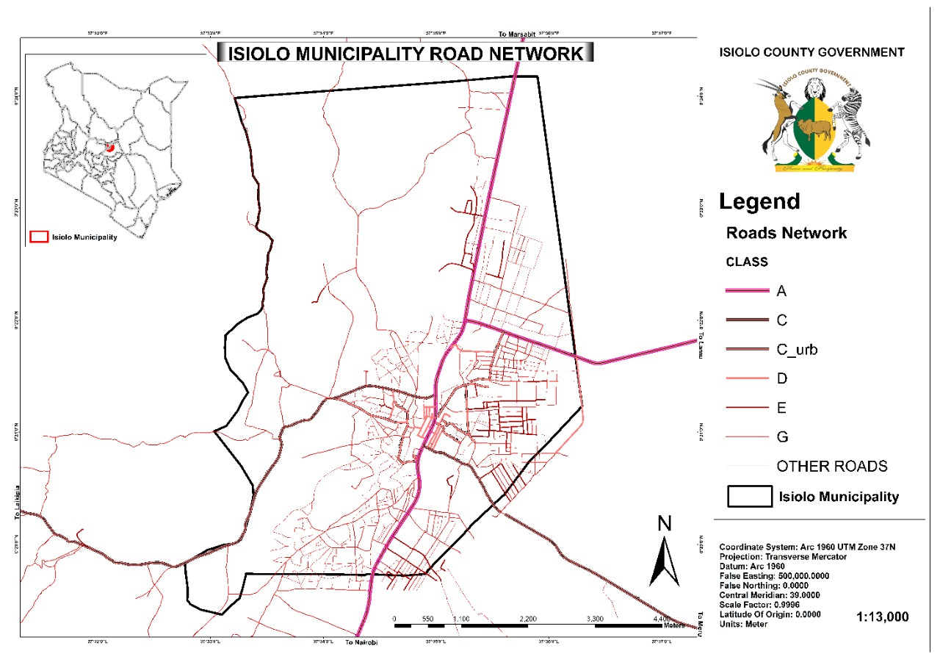

**Figure 8: Isiolo Municipality Road Network**

### **Transport Network and Distribution**

Transportation is a key element in the economic growth of any nation. It improves the access into different regions through connectivity and thus easing the movement of goods and people. The transportation system in Kenya is classified into road, rail, air, water and pipeline transport. Of all these, road transport is the most commonly used mode of transport throughout the country. The county has a road network of over 1275.5 km, out of which only about 42 km are bituminized. Gravel and earth surfaced roads account for 22 percent and 75 percent of the total road surface respectively. All the earth surface roads are impassable during the wet season and therefore call for continuous upgrading of these roads to all weather roads standards. The county has an airport located within the Isiolo Municipality. Isiolo airport is currently operational for local travels but is envisaged in near future to become fully operational to International airport under Vision 2030.The 1.4km runway has been done, modern passenger terminus to handle over 600,000 passengers annually and modern car parks has already been completed.

LAPSSET corridor project is one of the flagship projects of Kenya‟s Vision 2030 whose objectives are “To improve access and connectivity between Kenya, Southern Sudan and Ethiopia as well as to stimulate economic activity in the northern and eastern parts of Kenya. The proposed LAPSSET corridor is set to pass through Isiolo Municipality through Burat ward and is expected to be one of the driving engines of development in the county. The corridor that includes an oil pipeline, a highway and a railway line will pass through Garba Tulla, Kinna, Ngare Mara, Burat and Oldonyiro wards.

Road transport is the most popular system of transport, providing transport to both goods and passengers. Matatus, boda boda, bicycles and pedestrian movement constitute the bulk of road transport in Isiolo County. The County has few provision of cycle lanes, pedestrian walk ways and footbridges in all existing roads.

### **Information and Communication Technology**

Information communication technology in Kenya plays a key role in everyday lives of the people. Kenya is one of the top 5 fastest growing nation in terms of telecommunications and ICT infrastructure. Many sectors and institutions have embraced the use of ICT in improving service delivery. Some of the sectors that are ICT compliant include telecommunication industry, health, agriculture, finance, education, and the Government. For instance, the government has adopted the use of ICT in finance by establishing an Integrated Financial Management Information Systems. Other ICT platforms established by the government include Huduma centres and E-Citizen platform to enhance service delivery. ICT has been used more in the private sector as compared to the government. Among others they include, the use of mobile money transfer systems like M-Pesa, Airtel money and Equitel[10]. There is only one post office in the County, situated in Isiolo town and a sub-post office in Garbatulla urban centre. There are about 164 telephone connections (landlines) in the county. Around eight percent (2,090 km2) of the county have mobile network coverage leaving about 92 percent of the county without mobile phone network coverage. An important development goal is therefore to increase mobile network coverage in the county so that communication could be improved to better support social and economic activities.

### **Energy**

Energy, particularly electricity is recognized in Kenya Vision 2030 and the First MTP as one of the enablers to economic, social and political transformation of Kenya to “a newly- industrialized , middle income country providing a high quality of life to all its citizens in a clean and secure environment”. The County’s main source of energy is wood fuel. 85% of the households rely on fire wood as their main source of power, mainly for cooking. This has partly contributed to a decline in tree cover. Of the 31,326 households in the county; about 2,500 households have access to electricity. 85 percent of the trading centres and majority of schools and health facilities are also connected with electricity. 9% of the residents use petroleum products for cooking. In terms of lighting, 29% use electricity, 41.5% use petroleum products, 8.5% use wood fuel while 13.8% use solar for the same purpose. The rest of the population (7.3%) use other means. Lack of access to clean sources of energy is a major impediment to development through health related complications such as increased respiratory infections and air pollution. The type of cooking fuel or lighting fuel used by households is related to the socio-economic status of households. High level energy sources are cleaner but cost more and are used by households with higher levels of income compared with primitive sources of fuel like firewood which are mainly used by households with a lower socio-economic profile.

**Cooking Fuel**

**Figure 9: Percentage Distribution of households by Source of cooking Fuel in Isiolo County**

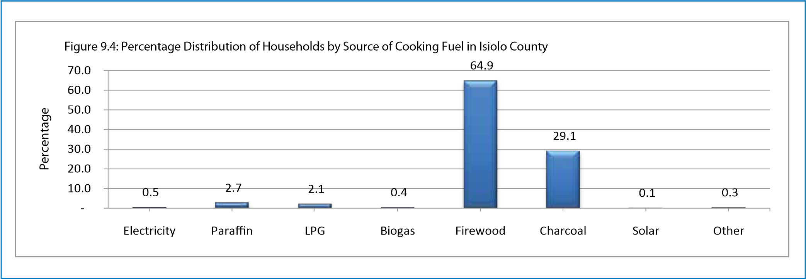

*Source: Exploring Kenya’s Inequality; Pulling Apart or Pulling Together Isiolo County Report 2013*

Only 2% of residents in Isiolo County use liquefied petroleum gas (LPG), while 3% use paraffin, 65% use firewood and 29% use charcoal. Firewood is the most common cooking fuel by gender with 63% of male headed households and 67% of female headed households using it.

Isiolo South constituency has the highest level of firewood use in Isiolo County at 94%.This is 40 percentage points above Isiolo North constituency, which has the lowest share at 54%. Isiolo South constituency is about 29 percentage points above the county average. Chari ward has the highest level of firewood use in Isiolo County at 98%.This is eight times Bula Pesa ward, which has the lowest share at 12%. Chari ward is 33 percentage points above the county average.

Isiolo North constituency has the highest level of charcoal use in Isiolo County at 39%.This is almost eight times Isiolo South constituency, which has the lowest share at 5%. Isiolo North constituency is about 10 percentage points above the county average. Bula Pesa ward has the highest level of charcoal use in Isiolo County at 74%. This is 72 percentage points more than Chari ward, which has the lowest share at 2%. Bula Pesa ward is 45 percentage points above the county average.

**Lighting**

**Figure 10: Percentage distribution of Households by Source of lighting Fuel in Isiolo County**

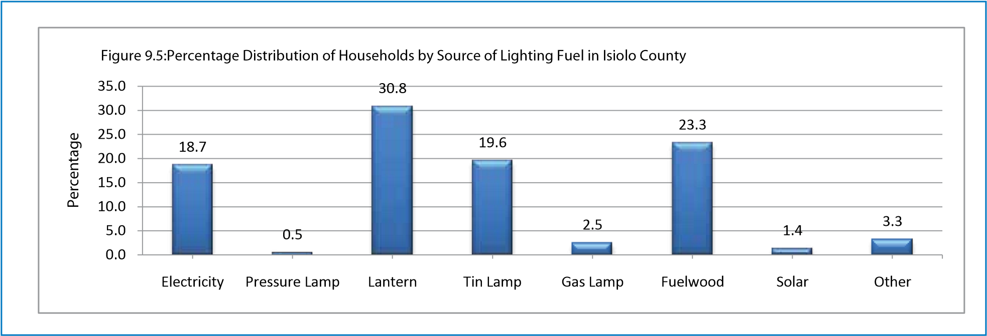

*Source: Exploring Kenya’s Inequality; Pulling Apart or Pulling Together Isiolo County Report 2013*

A total of 19% of residents in Isiolo County use electricity as their main source of lighting. A further 31% use lanterns, 20% use tin lamps, and 23% use fuel wood. Electricity use is more common in male headed households at 20% as compared with female headed households at 16%. Isiolo North constituency has the highest level of electricity use at 26%. This is 25 percentage points above Isiolo South constituency, which has the lowest level of electricity use. Isiolo North is 7 percentage points above the county average. Wabera ward has the highest level of electricity use at 54%. That is 54 percentage points above Chari ward, which has the lowest level of electricity use. Wabera ward is 35 percentage points above the county average.

### **Water**

According to UNICEF (2008), over 1.1 billion people lack access to an improved water source and over three million people, mostly children, die annually from water-related diseases. Water quality refers to the basic and physical characteristics of water that determines its suitability for life or for human uses. The quality of water has tremendous effects on human health both in the short term and in the long term. In Isiolo County improved sources of water comprise protected spring, protected well, borehole, piped into dwelling, piped and rain water collection while unimproved sources include pond, dam, lake, stream/river, unprotected spring, unprotected well, jabia, water vendor and others. In Isiolo County, 59% of residents use improved sources of water, with the rest relying on unimproved sources. There is no significant gender differential in use of improved sources with male headed households at 59% in comparison with 60% in female headed households. Isiolo North constituency where the municipality is located has the highest share of residents using improved sources of water at 60%.This is 2 percentage points above Isiolo South constituency, which has the lowest share of residents using improved sources of water. Isiolo North constituency is 1 percentage point above the county average. Wabera ward has the highest share of residents using improved sources of water at 88% each. This is 18 times Oldonyiro ward, which has the lowest share using improved sources of water. Wabera ward is 29 percentage points above the county average[11]. Water supply within the municipality is supplied by the Isiolo water and sewerage company (IWASCO). Isiolo water and sewerage company (IWASCO) is the gazetted urban water service provider and its water source is Isiolo River, two springs and 17 Boreholes.

**Figure 11 Water facilities in Isiolo Town**

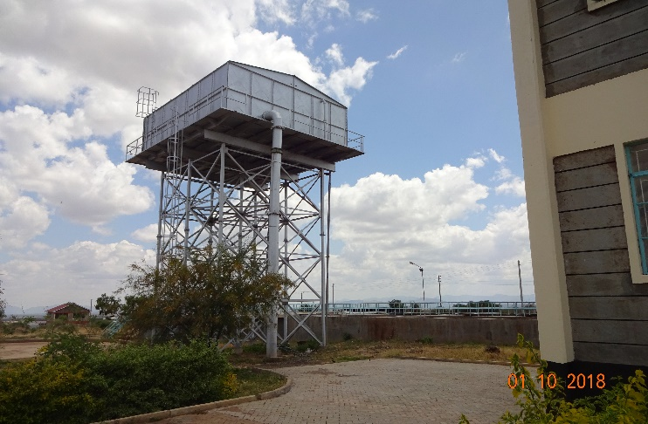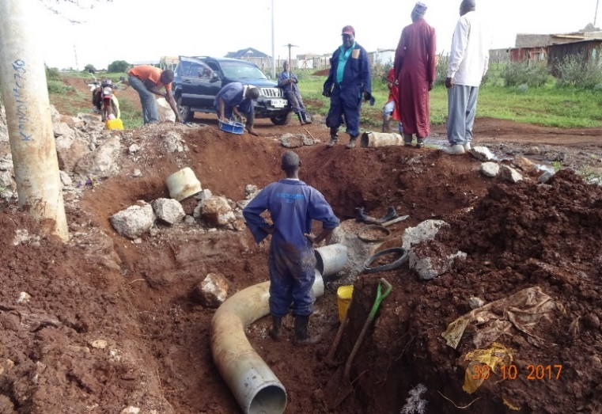

*Source: Isiolo Water and Sewerage Company Strategic Plan*

**Water Connectivity:** IWASCO currently serves 55,300 people (79%) out of a total population of approximately 70,000 in its area of jurisdiction (active and inactive connections). The WSP inherited 3,000 water connections from the Ministry of Water and has increased this number to 8,622 registered connections as at August 2018. The sewerage connection stands at 1600. Of the water connections, approximately 7,329 (85%) are active, and 1,294(15%) are inactive. Isiolo Water and Sewerage Company has 12 water kiosks and 12-yard taps within Isiolo town to serve low-income areas. The kiosks are in areas where the utility has not been able to construct a distribution network to connect households while the yard taps are outside individual’s compounds who are authorized to sell water to the neighboring households. Currently, overall water production stands at 4500m3/day against a daily demand of 10,000m3/day. This means that the utiltiy is not meeting half the demand of clean and safe water within it jurisdiction. It envisage that, this gap will be addressed by proposed construction of the new Crocodile Jaw dam along the Ewaso Nyiro River.

|  |  |
| --- | --- |
| Connection type | Number of active connections |
| Domestic | 7,990 |
| Commercial | 487 |
| Institutions | 145 |
| Total | **8,622** |

**Table 1: Active Water Connectivity by IWASCO**

### **Waste Management and Sanitation**

Sanitation refers to the principles and practices relating to the collection, removal or disposal of human excreta, household waste, water and refuse as they impact upon people and the environment. Decent sanitation includes appropriate hygiene awareness and behavior as well as acceptable, affordable and sustainable sanitation services which is crucial for the health and wellbeing of people. Lack of access to safe human waste disposal facilities leads to higher costs to the community through pollution of rivers, ground water and higher incidence of air and water borne diseases. Other costs include reduced incomes as a result of disease and lower educational outcomes. Nationally, 61 percent of the population has access to improved methods of waste disposal. A sizeable population i.e. 39 percent of the population is disadvantaged. Investments made in the provision of safe water supplies need to be commensurate with investments in safe waste disposal and hygiene promotion to have significant impact.

Only 40% of residents in Isiolo county use improved sanitation, the rest use unimproved sanitation. Isiolo North constituency where the municipality is located has the highest share of residents using improved sanitation at 43%. This is 9 percentage points above Isiolo South constituency, which has the lowest share of residents using improved sanitation. Isiolo North constituency is 3 percentage points above the county average. Bula Pesa ward has the highest share of residents using improved sanitation at 81%. This is almost 41 times Oldonyiro ward, which has the lowest share of using improved sanitation. Bula Pesa ward is 41 percentage points above the county average.

Poor drainage system in Isiolo town has resulted into disastrous flooding during rainy season in recent times and has devastating impact on health and livelihoods of the population. Storm floods often mix with sewage from overflowing latrines and sewers, causing pollution and a wide range of problems associated with the increased risk of waterborne diseases. In rural areas storm flood are mainly along Ewaso Nyiro River which drains into lorian swamp except for isolated cases of high seasonal flooding that affect pockets of settlements.

The provision of sanitation facilities in urban areas of the county is inadequate especially sewer systems. Household domestic sewage is channeled to sewerage treatment ponds. Where sewer system is lacking, on-site sanitation facilities are provided through use of septic tanks and pit latrines. In rural areas pit latrines dominate households and septic tanks serve institutions.

**Sewerage connections:** The utility by IWASCO has 1,600 sewerage connections that include domestic, commercial and institutional customers. Though the utility has an installed waste water treatment capacity of 2,200m3/day, it only receives 1,200m3/day. The underutilization of the facility is partly due to the fact that residents are not willing to connect to the sewer system due to the charges levied, and instead prefer the use pit latrines and septic tanks. The utility is liaising with Isiolo County Government on future expansion of the wastewater treatment plant site selection. In addition, the utility provides sewer services, through an exhauster truck which it hires out to dissipate septic tanks.

### **Social Infrastructure**

1. **Education**

Only 13% of Isiolo County residents have a secondary level of education or above. Isiolo North constituency where Isiolo Municipality is located has the highest share of residents with a secondary level of education or above at 16%. This is twice Isiolo South constituency, which has the lowest share of residents with a secondary level of education or above. Isiolo North constituency is 3 percentage points above the county average. Two wards, Wabera and Bula Pesa, which are within the municipality have the highest share of residents with a secondary level of education or above at 29% each. This is almost 10 times Oldonyiro ward, which has the lowest share of residents with a secondary level of education or above. Wabera and Bula Pesa are 16 percentage points above the county average. A total of 36% of Isiolo County residents have a primary level of education only. Isiolo North constituency has the highest share of residents with a primary level of education only at 37%. This is 4 percentage points above Isiolo South constituency, which has the lowest share of residents with a primary level of education only. Isiolo North constituency is 1 percentage point above the county average. Bula Pesa ward has the highest share of residents with a primary level of education at 47%. This is three times Oldonyiro ward, which has the lowest share of residents with primary only. Bula Pesa ward is 11 percentage points above the county average[12].

A total of 51% of Isiolo county residents have no formal education. Isiolo South constituency has the highest share of residents with no formal education at 60%.This is 13 percentage points above Isiolo North constituency, which has the lowest share of residents with no formal education. Isiolo South constituency is 9 percentage points above the county average. Oldonyiro ward has the highest percentage of residents with no formal education at 83%. This is almost four times Bula Pesa ward, which has the lowest percentage of residents with no formal education. Oldonyiro ward is 32 percentage points above the county average. The County has 125 primary schools of which 70 are public and 10 are private within Isiolo Municipality. There are a total of 624 primary school teachers and this implies that the teacher/pupil ratio is 1:37. The dropout rate is one percent implying that most pupils are transiting to secondary schools.

The current projection of primary school going children population is 35,989 within Isiolo Municipality. Non-formal education has not been formally rolled out in Isiolo. However, there is great need for the adoption of the same in order to provide education for children who miss out school early in life. These include the children in the streets, children with disabilities and young mothers among others. There are two operational youth polytechnics in the county namely St. Joseph Polytechnic which is privately owned and Uhuru Youth Polytechnic. The county has 25 secondary schools as per 2016 Kenya National Bureau Statistics (KNBS) data, of which 17 are public and 8 are private. Only six are boarding schools and the rest are day schools. The total enrolment for 2016 is 5,397 students (2,988 males and 2,409 females.) Teacher population in secondary schools stands at 236 with a teacher/student ratio of 1:23 an improvement from 2013 when the number of teachers stood at 61 and teacher-student ration of 1:30. However, still a great number of students‟ have to walk/travel for 5 km and above to reach the nearest secondary school. There are three tertiary institutions in the county. These are Kenya Medical Training College, St. Marys Secretarial College, and Isiolo ECD Training centre. There is one extra mural centre for Nairobi University in Isiolo town offering diploma courses. There are 55 adult literacy classes in the entire county and 30 are within Isiolo Municipality. The county has 2 vocational training centres, namely Uhuru in Isiolo and Merti in Merti Sub-County. The latter is not yet operational.

1. **Health**

The County health system is largely affected by competing challenges not meeting the standard number in any of the orientation area as per the health systems building blocks. Specifically, the indigenous cultural practices encourage high birth orders, early marriage, teenage pregnancy, cultural barriers like female-genital mutilation; have contributed to the high maternal and neonatal mortality. Over 68 percent of people in the county live in the rural areas where health facilities are inadequate, sparsely distributed and understaffed. There are two tier 3 health facilities (Isiolo and Garbatulla hospitals), 51 tier 2 health facilities and 36 established Community Health Units (Tier 1). Most of the primary health care facilities lack adequate personnel and health commodities. Most of the health facilities are located in Isiolo sub County. The medical reports from Isiolo County health department (DHIS, 2017) indicate that HIV prevalence has reduced from 4.9 percent in 2012 to 3.8 in 2017. The major affected areas are Isiolo town, Garbatulla, Ngaremara and Merti. The threat posed by HIV and AIDS is the increase of orphaned and vulnerable children and death of productive population. It also increases demand for health services and health care provision.

## **Economic Development**

### **Agriculture**

The County is prone to drought and water shortage often causing severe food insecurity. Agricultural production however has varied over the years due to the erratic and unreliable rainfall. This partly explains the high food poverty levels in the county. Within the municipality, rain-fed crops are grown in Bulla Pesa and Wabera wards where the black cotton soil retains moisture long enough to make crops mature. The livestock sub-sector is the most stable due to the expansiveness of the county and availability of natural vegetation. The sub-sector is the backbone of the county’s economy with over 80% of the inhabitants relying on livestock for their survival. Urban agriculture is also increasingly becoming an important activity in urban economies. It can contribute significantly to the well-being of farmers and other citizens, if properly managed. The growth of human settlements creates a competition between the traditional urban land uses and urban agriculture. Whilst regional and urban planners have generally accepted the peri-urban zone as a mixed zone in terms of land use categories (including urban agriculture), the intra-urban zone in most cases remains a preserve for “traditional” urban uses.

### **Mining**

The county is endowed with lots of minerals which has significant economic importance and left untapped and poorly explored. Geological surveys have shown that the county has untapped deposits of mineral such as blue and yellow sapphire, in Duse location, ruby in Raspu and Korbesa locations, limestone and biromix in Merti, and gas in Merti and Alango locations. The county has huge sand potential and the on-going exploitation in the central wards is haphazard and environmentally unsustainable. The county government has opportunity to explore the available environmentally sustainable opportunities in the mining industry to identify and regulate all mineral resources in the county. This should then be linked to market the available small scale extractions going on in different parts of the county for the benefit of the local community and county economy. The community developed the map below which shows few places with mineral resources that can be exploited to create wealth for the county

**Figure 12: Isiolo County Mineral Map**

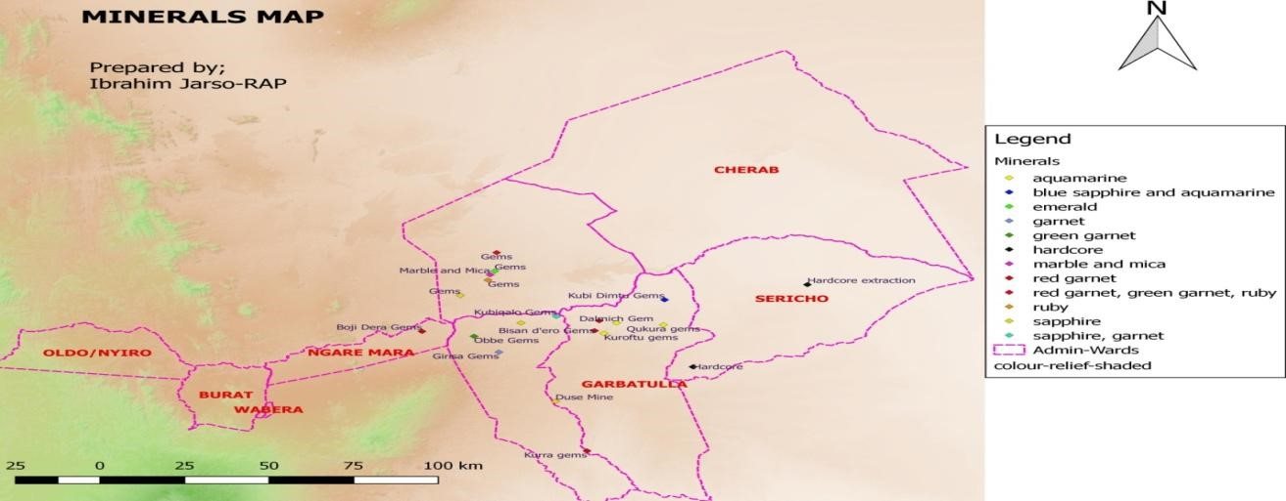

*Source: Isiolo County Integrated Development Plan 2018-2022*

There are patches of areas in the county where mining is an alternative livelihood for residents e.g., Duse mines where blue and yellow sapphires are extracted. The government is currently prospecting for petroleum oil in Chari and Cherab wards in Isiolo North Constituency. Sand harvesting is much done in most parts of the county but commercial one is done in Burat, Ngaremara and Kinna.

### **Tourism and Hospitality**

The county tourist attractions are categorized as: nature and wildlife, culture, heritage and community-based tourism, adventure, agro-tourism, eco-tourism. There are a wide range of hotels and campsites in the county which offer accommodation to tourists. All these major hotels are located in Isiolo north Sub County where the Municipality is located. The hotel include: one five star hotel with a bed capacity of 34, two four stars hotels with total bed capacity of 78, three 3 star hotels with total bed capacity of 250, one two star hotel with a bed capacity of 311, three 1 star hotel with total bed capacity 348 and several unclassified hotels and restaurants within Isiolo town.

The county has three game reserves namely; Shaba, Buffalo Springs, Bisanadi. Samburu and Meru national park also borders the county forming part of the northern tourist circuit. The parks and game reserves in Isiolo County are famously known for their natural beauty and abundance of fauna and flora including species which are endemic. The county is very rich in terms of diversity of wildlife species. The main ones found in the county includes: African wild dog (Lycaon pictus), giraffe, elephant, ostrich, monkeys, antelopes, impala, giraffe, leopard, waterbuck, lesser kudu, greater kudu, hippo, grevy zebra, buffalo, lion and over 300 species of birds and beisa Oryx. These wildlife populations in the County are being decimated by poaching and pastoralist encroachment to wildlife inhabitant. There are no game ranches in the county. There are five NRT facilitated conservancies (Nakupratt-Gotu, Leparua, Biliqo Bulesa, Nasulu, and Oldonyiro Community Conservancy) as community conservation models that serve as corridors for wildlife as well as migration areas. The NRT through its trading arm, NRT-Trading has been supporting communities in these conservancies by way of commercial livestock off take.

### **Trade Industries and commerce**

The county has no manufacturing establishments /industries despite a huge potential in livestock product based industries. Currently, there are only 10 Jua Kali associations and several unorganized artisans whose number needs to be determined. There are upcoming micro and small industries in the county. There is only one major town in the county; Isiolo, which serves as the county’s administrative headquarter. The other upcoming urban centres are: Garbatulla, Modogashe, Kinna, Merti and Oldonyiro. The main types of markets in Isiolo are five retail and ten livestock markets. The ten major livestock markets in the county are found in Isiolo central, Garbatulla, Belgesh, Eskot, Duse, Kinna, Modogashe, Merti, Kipsing and Oldonyiro. The main livestock trading include cattle, goats, sheep and camels. Buyers come from Nairobi, Meru, and as far as the coastal region of Kenya. The four retail markets in Isiolo include Isiolo, Kinna, Merti, Kipsing and Oldonyiro. The main traded goods in urban centres and local markets are livestock, fruits, vegetables, maize, beans, wheat, and millet and - a cereal mostly cultivated in Meru. Most of the maize and beans fruits and vegetables come from other counties. There is potential for establishing spaces for traditional herbs and medicines, gums and resins, camel milk markets.

There exists an informal Jua kali sector in Isiolo central that includes blacksmiths popularly known as Tum tum, dressmaking, embroidery and artefacts and basketry. The county plans to establish 3 Industrial parks in every sub county that are appropriately structured with the following objectives:

* + Facilitate transfer of technology and promote local enterprises.
  + Act as a repository for traditional knowledge and skills (documentation).
  + Provide other value addition services together with high quality space and services
  + Promote business planning and incubation

There are 2 industrial centres one in Isiolo Central and another in Modogashe that have not been operationalized but aimed at developing skills to the locals to engage in trade that can be done at the industrial parks. There are no major industries but with the completion of the Isiolo Export Abattoir, It is expected that there will be inter linkages in the economy and more industries will emerge. This will include: - Pet food industries - Hides and skins and bones (livestock bi-products) - Commercial feed industry. There is also a huge potential in gums and resins as well as Aloe vera. There are several MSMEs in the county, with only a few registered under the registrar of companies and others have business names. There are also registered Juakali Associations within the county. Other MSMEs are registered as self-help groups, SACCOs while others belong to merry-go rounds that are not registered

### **Employment**

Wage Earners accounts for 14.5 percent of the county’s population. Majority of the wage earners are employed in the public sector and hotel industry. Over 85.5 percent of the populace is not engaged in formal employment due to high illiteracy levels among the locals and lack of industries. The main formal employment zone in Isiolo is Isiolo town. The proportion of skilled labour is also low due to lack of technical and vocational training institutions in the county. The informal sector covers small scale activities that are semi-organized, unregulated and uses low and simple technologies while employing few people per establishment. The ease of entry and exit into the informal sector, coupled with the use of low level of technology at all makes it easy avenue for employment creation especially for the youth. About 60 percent of the county’s population is in rural self-employment. 15 percent is in the urban self-employment and are doing retail trade in various commodity sales such as Miraa trade, most of the rural dwellers are engaged in livestock trade. The labour force constitute about 52.12 percent of the county’s population. This percentage is projected to rise by end of 2022. The county experiences high level of unemployment with over 70 percent of the labour force not formally employed. This is due to high illiteracy levels coupled by lack of skills. Training and empowerment are key strategies that the county will focus in the five-year period plan.

# **CHAPTER THREE: URBAN DEVELOPMENT STRATEGIES**

## **Overview**

This chapter comprises of policies, strategies and actions necessary to achieve the objectives of this plan for the next 5 years. The plan comprises of development proposals to serve as a roadmap for integrated and sustainable urban development of Isiolo Municipality through five interlinked strategies namely: social development strategy; Environmental and Natural Resource development strategy; Sanitation and Waste management strategy; economic development strategy; human settlements strategy; transport, communication and infrastructure strategy; and governance strategy.

## **Policies, Strategies and Actions**

### **Social Development Strategy**

Interventions and activities for achieving social development goals are in view of achieving objectives mainly related to population and demographics, Education, health, culture as well as improving the quality of housing. The overall objective of the social development strategy is to improvement and the quality of life of all people, especially people who are poor, vulnerable or marginalized. At its core is a focus on addressing poverty, inequality and social ills while providing for the participation of people in their own development. The development challenges to be addressed include high levels of illiteracy, disease burden, poverty, inequality, vulnerability to climate shocks and poor access to service delivery. The Municipality will aim to promote the implementation of sustainable urban development programmes with housing and people’s needs at the center of the strategy, prioritizing well-located and well-distributed housing schemes in order to avoid peripheral and isolated mass housing developments detached from urban systems. The following strategies will define the social development Agenda:-

**Desired Outcome of the Social development strategies and Action plans**

1. The Municipality will promote housing policies that support the progressive realization of the right to adequate housing for all as a component of the right to an adequate standard of living, as well as integrated housing programmes that promote provision of adequate, affordable, well connected and located housing for different income groups of society with special attention to the proximity factor and strengthening of the spatial relationship with the rest of the urban fabric and the surrounding functional areas.
2. The Municipality will promote the development and enforcement of legislation, planning and building regulations in the housing sector, including, as applicable, resilient building codes, standards, development permits, land use by-laws and ordinances, combat and prevent speculation, displacement, homelessness, and arbitrary forced evictions.
3. The Municipality will promote the provision of sustainable housing as a driver for economic development, and note its contribution in stimulating productivity in other economic sectors, recognizing that housing enhances capital formation, income, employment generation, and savings, and can contribute to driving sustainable and inclusive economic transformation at the national, county, and local levels.
4. We recognizes the youth as a key resource that can be tapped for the benefit of the county and addresses issues affecting young people by providing broad-based strategies that can be used to give the youth meaningful opportunities to reach their maximum potential. We will create employment to the youth by engaging them in community development projects that lead to economic empowerment. They will be trained and organized into organized Savings and Credit Cooperative Organizations (SACCOs) and encouraged to venture into self-employment and establish enterprises to generate additional income
5. Promote proactive training and Education for young people and children to access quality education and vocational training opportunities. Work with County government to support policies that increase education opportunities for residents within Isiolo Municipality.
6. The Municipal administration will work with the County government to upgrade and modernize the existing health facilities within the municipality to ensure provision of quality health care. The plan also proposes additional health facilities to match population increase. Their location should be geographically, socially and economically accessible.
7. Under the social development strategies, the Municipality will also integrating Gender in Urban Development. The municipality will work with the county government to put in place policies, legislations and institutional frameworks to mainstream gender and social inclusion of marginalized groups into urban development.

### **Environment and Natural Resources development strategy**

The Kenyan economy is dependent on its natural resources. However, poor natural resource management, unsettled resource governance structures and rapid population growth, have put great strains on these resources. Present critical issues include land degradation, land-use conflicts, lost opportunities for sustainable natural resource utilization, depletion of water catchment areas, and a serious loss of biodiversity. The effects have been particularly adverse in the arid and semi-arid regions of the country, where the environment is threatened by increasingly unsustainable use of the areas with the highest potential for production during the dry season and which are seeing expanding agriculture, fuel-wood collection, charcoal burning, deforestation, and localized overgrazing – all exacerbated by the impacts of climate change. The Municipality will work with the county government department of environment and natural resources to promote sustainable management of environment and natural resources. According to the County Intergtreated Development Plan 2018-2022; the sector is composed of Water, Environment, Natural Resources, Energy and Climate Change sub sectors. The overall development objective is to promote sustainable utilization and management of water, energy, environment and natural resources for socio-economic development.

The County priority focus on Natural resource management is on enhancing disaster preparedness in all disaster-prone areas; Improve capacity for adaptation to global climatic change; Ensure application of Integrated Water Resources Management (IWRM) in the county with a view to harvesting of flood and river water; Promote efficient adaptation measures for productive and sustainable resource management in the county; Mainstream dry land issues into all county development plans and policies; Involve and empower communities in the management of county ecosystems and promote environmental education and awareness; Gazette and manage emergency drought reserve areas and encourage the development of buffer areas of forage and crop production as part of contingency planning; Mainstream environment climate foresight and climate adaptation into planning at all levels by strengthening the climate resilience of communities in the county and promoting sustainable livelihoods; Jointly develop and implement harmonized regional approaches for sustainable management of trans-boundary resources; Strengthen Environmental Governance and harmonize sectoral policies, legislation and regulations; Mainstreaming of climate change into all water resource management plans and actions; and Develop and promote the use of green energy. At the Municipal level the desired outcome are as listed below:-

**Desired Outcome of the Environment and Natural Resource Development Strategies**

1. Increase coverage and access to safe water in Isiolo Municipality by strengthening synergies in integrated water resources management through close working collaboration with department of water and sanitation and Isiolo Water and Sewerage Company. This will entail increasing water sourcing and storage capacity. Developing long term Municipal water integrated management master plan.
2. Improve protection and conservation of the environment; reduce environmental degradation; strengthen natural resources management; improve vegetation cover resources management improve vegetation cover and reduce environmental pollution.
3. Work with the Isiolo County Assembly to enact policies and legislations that provides an appropriate legal and institutional framework for the management of the environmental matters as well as an enforcement tool of impact assessment and audit in relations to development projects within the municipality.
4. We will facilitate the sustainable management of natural resources in a manner that protects and improves the urban ecosystem and environment, reduces greenhouse gas emissions and air pollution, and promote disaster risk reduction and management.
5. The municipal administration will facilitate the sustainable management of natural resources in a manner that protects and improves the urban ecosystem and environment, reduce greenhouse gas emissions and air pollution, and promotes disaster risk reduction and management.

### **Sanitation and Waste management**

Effective, efficient and cost economical waste management facilities are crucial if industrial and enterprise activity is to flourish and develop in a balanced way across various regions of Kenya. Kenya is urbanizing fast and the amount of solid waste generated is escalating posing serious solid waste management challenges. As the rate of urbanization increases it’s estimated that the amount of municipal waste generated will increase from 2,000 tons per day in 2012 to approximately 10,000 tons per day by 2025.The bulk of these waste is generated in major urban areas. Most of the urban areas are devoid of solid waste management facilities. Dumping sites are almost nonexistent and where they exist they are poorly sited, capacity has been exceeded and are poorly managed[13]. Isiolo county department of energy, environment, climate change and natural resources is responsible for solid waste management within Isiolo town. Solid waste collection and disposal in Isiolo town have been contracted to a private entity, who continues to use the County Government’s transportation vehicles. The disposal site is managed by the County environment department, and is served by a fairly maintained motorable access road. The fence has been completely vandalized making control of scavenging animals and people a challenge. Additionally, Sewerage system coverage in Isiolo Municipality is low. Most of the urban areas are not supported by a sewer network but depend on septic tanks and pit latrine modes which are not sustainable.

It is estimated that Isiolo County loses 139 million KES each year due to poor sanitation. This includes losses due to access time, premature death, health care costs and productivity. This estimate does not include some costs that could be significant (such as water pollution and tourism) and is therefore likely to under-estimate the true cost of poor sanitation[14].

**Desired Outcome on Sanitation and Waste management strategies**

1. The municipal administration will ensure increased private sector participation in environmental management in areas of solid waste management that incorporates the 3Rs (Recycle, Reduce and Re-use) and initiatives that include reducing emissions from deforestation and forest degradation (REDD+) as well as the role of conservation, sustainable management of forests and enhancement of forest carbon stocks.
2. The Municipality will work with the county government to support promotion of extended producer (polluter pays) responsibility schemes, including waste generators and producers in the financing of urban waste management systems.
3. To Increase access to sanitation facilities in the Urban areas through rehabilitation of existing ponds and Improve sewer reticulation system
4. We commit to foster healthy societies by promoting access to adequate, inclusive, and quality public health services; a clean environment taking into consideration air quality guidelines, social infrastructure and facilities such as health-care services.

### **Economic Development**

Kenya’s principal cities and urban areas are the engines of economic growth, accounting for about 70% of GDP. The urban economy is dominated by the informal sector. The formal sector has over the last two decades suffered major changes especially closure of industries and resurgence of the service sector. The Structural Adjustments Programme (SAP) implemented in 1980s-1990s, coupled with globalization, led to major structural changes in the urban economy. These changes were largely negative. It is estimated that 76.5% (5.9 million people) of Kenya’s labour force works in the informal sector, and that this labour force continues to grow each year. The sector consists of varied and dynamic small-scale activities and employment relations that are not registered with the Registrar of Companies and are characterized by low productivity and income. Most businesses in the sector are own-account enterprises; majority of which are Micro and Small Enterprises (MSEs), which include hawking, agro-businesses, food merchandising, the service industry, artisanship, clothing and textiles, and informal housing[15].

The backbone of the County‟s economy is livestock sub-sector. Over 80 percent of the inhabitants rely on livestock for their livelihoods. Nomadic pastoralism is prominent in the county and defines the lifestyle of most of the county‟s inhabitants. It has had a negative impact on the environment due to the tendency of overgrazing caused by overstocking. Intensive dairy production is less prominent economic activity in the county but lately gaining importance as a business with increasing urban demand. The main cattle breeds are Zebu and Boran which are drought resistance breeds and are kept mainly for beef production. Goat breeds include the Galla (main), the small east African, Saanen, toggenberg, the swiss alpine and many crosses of local and exotic breeds. The black head Persian breed is the dominant sheep breed in the county. The major breeds of camels found in the county are the Somali, Turkana and the Rendille/Gabra. Poultry breeds include the local chicken and to a small extent exotic broilers and layers in urban areas. The markets for the county‟s livestock are mainly in Nairobi and other neighbouring counties. In order to sustain the livestock industry in the county several measures and policy interventions need to be put in place to improve the industry and to mitigate the negative effects of overstocking.

The county has potential in bee keeping, however this has not been achieved because of challenges like drought, inadequate investment among others. Cooperation with stakeholders to enhance bee keeping in the county as an economic enterprise is required. The county has one micro private honey refinery in Isiolo town which is currently operating below capacity because of low honey production.

**Desired Outcome on Economic Development strategies**

1. Increased private sectors participation and investment in socio-economic activities that create decent jobs and livelihoods opportunities for youth, women and vulnerable populations with the municipality
2. Develop Isiolo Municipality Urban economic development plan with the support of private sectors, civil society and donor agencies to take into account urban economy through integration of urban planning and development in the development agenda
3. Ensure a risk-informed urban development paradigm and managing climatic impacts and disaster risks to achieving the objective of resilient socio-economic development.
4. The Municipal administration will work to assist informal traders to grow and diversify, and to experiment with community-based enterprises and the social economy as a way to develop local skills, provide useful services, and support livelihoods
5. The Municipality will adopt a more determined approach when deciding on the most appropriate locations for business and industrial development in the towns. Currently, the spatial pattern of investment is somewhat haphazard, with investment driven by where developers can access cheap land or existing infrastructure, rather than planned from a socioeconomic and environmental perspective.
6. The municipal administration will seek for collaborative approach to strengthen municipal institutional capacity in economic development. Economic development requires specific skills and competences, in particular the organizational capacity to engage with external role-players and to champion local interests. Other capabilities needed include strategic leadership, economic literacy, networking, partnership-building and negotiation with wider interests, to ensure that job-creating investment is championed, while safeguarding a proper balance between economic objectives and environmental and social considerations. The Municipality will consider appointing economists, project facilitators and people with appropriate business experience
7. The municipality will Initiate differentiated economic development strategies for Isiolo town. The economic development strategy will be a special section of the municipal growth management strategy, with a medium-term plan expressed in the IDP. The strategy will be based on the towns distinctive strengths and weaknesses, and recognize certain imperatives, such as the need to grow the resource base and reduce consumption. It will seek to position Isiolo town (in relation to key industries, occupations, markets and investment opportunities) relative to other towns in the County.
8. Strengthen roles and leverage partnerships with other economic stakeholders. TheMunicipality will engage with external economic stakeholders (including other spheres of government) to develop a shared understanding of economic development and jointly solve problems through sector forums (manufacturing, business services, property development, informal enterprises, etc.) or regular learning forums (e.g. an annual Isiolo Municipal economy’ summit).
9. Create the local conditions for supporting enterprise development and growth.This will take the form of removing barriers that stand in the way of enterprise development. At a local level, economic development requires available serviced land, essential physical and telecommunications infrastructure, labour, skills, and efficient administration of building and environmental regulations
10. Support community-based enterprises and work. Given the large deficit of decent jobs in the mainstream economy, public employment programmes should be used imaginatively to support community-based initiatives and other ‘bottom-up’ activities, particularly in townships and informal settlements.
11. Support urban livelihoods and the informal sector Given Isiolo County’s high unemployment rate, The municipal administration will seek to support all kinds of entrepreneurial activity, both directly and by not imposing undue restrictions on their operations. Panel beaters, mechanics, hairdressers, cell phone repairers, tailors and cobblers, artists, recyclers, waste pickers, craftsmen, street traders and other home-based industries all have a part to play in growing the economy.

### **Land and urban Planning**

The constitution of Kenya 2010 under Article 60 calls for efficient, productive and sustainable use of land. It also, under Article 260, defines land broadly to mean the surface of the earth and the subsurface rock; any body of water on or under the surface; marine waters in the territorial sea and exclusive economic zone; natural resources completely contained on or under the surface; and the air space above the surface. Sessional Paper No. 3 of 2009 on The National Land Policy aims at optimizing the use of land resources by ensuring that all land is put into productive use on a sustainable basis by facilitating the implementation of key principles of land use, productivity targets and guidelines as well as conservation[16].

Efficient land governance and management ensures stability and predictability in the land market, and contributes to the growth of inclusive and multi-functional urban spaces. This lever is critical for achieving integrated urban planning (Lever 1), transport and mobility (Lever 2), sustainable human settlements (Lever 3), and inclusive economic growth (Lever 6). Strategic land governance and management can promote urban areas that are more efficient, effective and inclusive. Arrangements must allow for closer alignment at municipal level of land-use planning, infrastructure investment and the development of land. The municipality recognizes that all players in urban land markets have a role to play in securing urban land in both formal and informal markets. They include, developers, the banking sector and investors, housing micro-finance institutions and other stakeholders, such as end users and the poor. The Counties vision on Land use is to ensure a well-planned highly connected and accessible territory with secure tenure for land and properties. The mission is to promote efficient administration and management of land and facilitate access and interconnectivity for sustainable economic development. The goal is to have a properly planned county and urban spaces with smooth connectivity in access for the rural and urban areas. To achieve efficient land governance and management, the following priorities are identified.

**Desired Outcome on land and Urban planning strategies**

1. The Municipality with work with the county government and all other relevant stakeholders to design strong land governance arrangements that provide transparency, accountability and provide true security of tenure that can be trusted by the citizens, business and the financial institutions.
2. Ensure that county policies on land use, sets out a sound overall framework for dealing with land use planning, development control and environmental management issues. Proper planning will provide for well-coordinated development of urban and peri-urban areas in terms of housing, commercial, industrial and infrastructure development to accommodate changes in lifestyle and economic activities.
3. Continually build trust between County Land Governance arrangements and the business community to ensure their serious involvement in the land market. Create a dialogue with the commercial sector to design and implement innovative approaches to funding through group savings and cooperatives.
4. Lobby the county government through the department of Lands and physical planning to ccreate and sustain land information Management System that is comprehensive, transparent and easily accessed by all stakeholders. This is essential for well-functioning land management and administration services and will contribute significantly towards a reduction in land based corruption.
5. Ensure that the outcome of the policy change on land use, will strengthen the relationship between citizens and the land; by allowing people to own and govern their lands and vesting ultimate ownership of community land with the community or, where land is limited, ensuring that people have access rights to land through rental agreements.
6. Work closely with the department of lands and Physical planning to improve Urban Land Management including addressing Urban Sprawl. This will requires physical information of vulnerable land and identifying available land; protecting watershed, vegetation, topography, drainage courses; guiding land development through mechanisms (land pooling, land banking, etc.) and incentives; and locating accessible lots in close proximity to socio-economic opportunities.
7. Promote safe, inclusive, accessible, green, and quality public spaces, including streets, sidewalks, and cycling lanes, squares, waterfront areas, gardens, and parks that are multi-functional areas, as drivers of social and economic development for increased socio-economic and property value, social interaction and inclusion, human health and well-being, and cultural expression to promote living together, connectivity, and social inclusion.
8. Promote increased security of tenure for all at all levels of government, recognizing the plurality of tenure types. Work with the ministry of land and physical planning to promote land inventory systems through gathering of information and data on land and property and ensure enforcement of planning and building regulations within the municipality.

### **Urban and Human Settlements Infrastructure**

The overall objective of the human settlement strategy is to improve the social, economic and environmental quality of settlements and the living and working environments of all people in the urban and rural areas of the County. This is meant to achieve sustainable urban and rural development by achieving a balanced growth in all spatial units namely Sub-counties and Wards as well as enhance spatial planning decisions that relate to urban growth, land use, housing, and transport, guarantee equitable distribution of infrastructure and services, and ensure optimal utilization of land as a scare resource in the county. Integrated and sustainable human settlements are key to creating more living and working conditions that are humane, safe and environment-friendly. Housing is just one of the interventions required to create urban environments that are liveable, integrated and multi-functional. Also needed are mobility choices to improve access, economic interventions to better people’s livelihoods and appropriate land use to facilitate more integrated and inclusive neighbourhoods. Integrated and sustainable human settlements result in:

* Improved quality of life for all citizens who have full access to all basic services and the multiple social, cultural and economic opportunities of urban areas;
* Multi-functional spaces with varied shelter, locational and economic choices; and
* Well-serviced, safe, cohesive and vibrant communities.

The physical environment and public spaces in many areas within the municipality are neglected and poorly planned, designed and managed, particularly in the unplanned settlements.

The lack of quality ‘green’ and safe public spaces, which are the lifeblood of vibrant and successful cities and towns, has a negative effect on real or perceived threats to the safety of users in the existing spaces, especially women and girls. Inadequate housing exposes citizen to hazards and health threats, with one of the most serious threats being overcrowding, which enhances the transmission of diseases among the household members, especially children, older persons and people with disabilities. Many areas of the municipality contain structures that do not meet building codes. This makes them vulnerable to the impacts of climate change, which go beyond exposure to extreme weather events.

The municipalities ultimate goal of sustainable human settlements is a decent standard of living, which

Includes access to transport, safety and security, adequate healthcare, nutrition, housing, water, electricity and sanitation services. To achieve integrated sustainable human settlements, the following priorities are identified.

**Desired Outcome on Sustainable Urban and Human settlement structures**

1. Develop norms and standards for urban design;urban design principles should produce safe, liveable and inclusive urban spaces, resultingin an improved quality of life for all residents. Creating sustainable human settlements is notsimply about building houses and rental stock, but includes the provision of social, public andeconomic facilities. Therefore, differentiated norms and standards need to be developed that gobeyond engineering services, to include social facilities, public spaces and green infrastructure.
2. Transform public spaces into safe places of community life: Increased attention will be given to creating, maintaining and activating quality public open spaces, such as parks, squares, playgrounds and transport interchanges. These spaces should be seen as shared centres of community life and generators of social inclusion and cohesion. The principles of Crime Prevention through Environmental Design will be actively encouraged and supported, along with municipal norms and standards in urban design, planning and management that give priority to safety considerations in enhancing people’s experience of the built environment. The spaces will be designed to be barrier-free, to accommodate young children, the elderly, and adults with babies and the disabled.
3. Promote equitable access to sustainable basic physical and social infrastructure for all, including affordable serviced land, safe drinking water and sanitation, waste disposal, and mobility for all in urban and human settlements.
4. Promote access for all to safe, affordable, accessible, and sustainable urban mobility, by integrating transport and mobility plans into overall urban and territorial plans and promoting a wide range of transport and mobility options, in particular through supporting:- i. A significant increase in accessible, safe, efficient, affordable, and sustainable infrastructure for public transport as well as non-motorized options; ii. Better and coordinated transport-land use planning, which enhance connectivity between urban, peri-urban, and rural areas.
5. Promote better coordination between all relevant departments and institutions that deal with transport, infrastructure, urban and territorial planning at the county levels to ensure harmony and sustainable urban and municipal development.
6. Promote adequate investments for accessible and sustainable infrastructure and service provision systems for water, sanitation, and hygiene, sewage, solid waste management and urban drainage, and storm water management, in order to improve safety against water-related disasters.
7. Ensure development occurs close to employment, services, and transport links. This is so as to encourage active modes and accessibility, and reduce pressure on resources and infrastructure. The expectation is that newest developments will occur along the proposed growth poles and corridors of the county.

### **Transport, Communication and Infrastructure**

The transport sector plays a pivotal role in the growth of Kenya’s economy. Vision 2030 aspires for a country firmly interconnected through a network of roads, railways, ports, airports, water ways, and telecommunications. The National Transport Policy aims at achieving a world-class integrated transport system responsive to the needs of people and industry by developing, operating and maintaining an efficient, cost effective, safe, secure and integrated transport system that links the transport policy with other sectoral policies.

Economic infrastructure provides the essential inputs and links for the economy to function, while social infrastructure provides the structures for the care, education and security of the population. Infrastructure is consumed as a bundle of services, and so the planning, financing, constructing, operating and maintaining of each service needs to be done in an integrated and sustainable way. Furthermore, development decisions can affect exposure and vulnerability to multiple hazards over time. Measures that can be taken to reduce losses and build resilience should be considered. How infrastructure is planned, financed and operated is a powerful instrument for steering the development of an efficient, equitable and resilient urban form and facilitating access to social and economic opportunities

Integrated urban infrastructure results in:

* Universal access to basic social and other services, which supports equality and inclusivity;
* Environmental benefits, through the protection of ecological resources;
* Sustained economic activity, growth and job creation; and
* Urban resilience.

**Desired Outcome on Transport, communication and Infrastructure**

1. Advocates for compliance with air quality standards and strengthening of enforcement capacity as well as promotion of efficient non-motorized, non-polluting and efficient infrastructure for mass transport system within the municipality.
2. Undertake the development and maintenance of recreational parks and greening initiatives in various parts of the municipality leading to improved air quality and cleaner environ
3. Lobby County assembly to develop urban transport policy that aims at developing an integrated, balanced and environmentally sound urban transport system in which all modes efficiently play their roles to improving Access to Sustainable Means of Transport.
4. Provide a framework for development and management of public service termini by the private sector through public private participation
5. The designated terminal facilities in the towns within the municipality shall be planned, constructed and managed to accommodate parking spaces for the private vehicles and public transport system
6. The Municipality shall provide guidelines to regulate environmental conservation in the development and maintenance of the transport network
7. Building resilience through integrated urban infrastructure.Conservation or restoration of ecosystems provides cost-effective options for climate change adaptation and disaster risk reduction. Healthy catchment areas outside cities and green open spaces within cities help to slow the flow of water and increase its infiltration. Furthermore, infrastructure should be constructed in a manner that makes communities less vulnerable to disasters and strengthens their resilience. Municipalities should also ensure that urban infrastructure is constructed and maintained in accordance with building codes and standards.

### **Urban Governance**

Urban governance involves managing both government and non-government players, such as the private sector, media and civil society. It requires collaborative and visionary strategic leadership, supported by strong management and clear responsibilities, authorities and accountabilities. A crucial element is an intergovernmental institutional framework that specifies the delegated responsibilities, encourages transparent communications among players, and enforces a code of conduct. Urban governance also has to recognize the distinctive social, demographic and economic trends of different towns and cities, so that the demands of urbanization can be translated into appropriate socio-economic development. Well-coordinated public sector action, supported by the private sector and other stakeholders where relevant, is crucial for creating urban spaces more compact, productive and equitable. Governance systems and mechanisms provide greater opportunities for an integrated development approach. This can enable synergies with infrastructure investment and maintenance, land use management, livelihood creation and ecosystem services protection, with resilience building as an overarching objective.

Good urban governance can be construed to connote equity, inclusivity, participation, responsiveness, transparency and accountability, rule of law, efficiency, effectiveness and consensus oriented. In this context, governance refers to the process of decision making and implementation. The implementation of the urban development strategy will be undertaken by a multiplicity of actors and hence the need for a coordinated approach. The lead agency will be Municipal Board. The department of Physical Planning will exercise technical leadership and ensure that physical planning is coordinated between the other agencies and ministries involved in physical planning. Departments and Agencies (MDAs) identified in the plan to administer the policies and measures are required to translate them into action plans, programmes and projects and to include such programmes and projects in their subsequent sector plans. Partnerships between the municipality and county governments and the private sector will be established to facilitate planning.

**Desired Outcome on Urban Governance**

1. We recognize that realization of the commitments on implementation of integrated urban development plan for the municipality will require an enabling policy framework and legislation at County level, participatory planning and management of urban spatial development, and effective means of implementation, complemented by multi-stakeholder engagement cooperation as well as capacity development efforts, including the sharing of best practices at all levels.
2. We will promote urban policies and regulatory frameworks, and mainstream sustainable urban and territorial development as part of integrated development strategies and plans, at all levels.
3. We will foster effective participation, collaboration and coordination among all relevant stakeholders, including county governments, international and regional organizations, the private sector, civil society, women and youth organizations, representatives of persons with disabilities, professionals, academic institutions, trade unions and employers’ organizations.
4. Establishment and operationalization of Isiolo Municipality Urban Forums (MUFs): MUFs will be multi-stakeholder platform that seek to promote constructive urban dialogue and consensus building on key urban issues relevant for sustainable local urban development within the municipality. Guided by participatory principles the MUFs will provide a model citizen’s platform. The platform will be used as forums for citizen participation in the planning, budgeting, decision making and management of municipal affairs. Through the MUF platforms, citizens will be educated and sensitized on their rights and obligations in the governance and management affairs of their towns.
5. Promote public private sector engagement. The Public Private Partnership Act, 2013 provides for the participation of private sector in the financing, construction, development, operation maintenance of infrastructure or development projects of the government through concession or other contractual arrangements. This facilitates mobilization of Domestic and International private sector investments as well as providing a clear and transparent process for project development.
6. Promote citizen participation in urban governance. Citizens must play their role to ensure the highest possible service delivery in urban areas. Most citizens, notably the middle class, particularly in urban areas do not participate in matters of urban governance and management. Some forms of exclusion such as self-disenfranchisement is common among the middle class and excludes citizens from participating in decision making processes such as election of leaders within their urban jurisdictions, payment of rates, waste management, public budgeting debates and attending local barazas among others.
7. Work with Law enforcement agencies to enhance urban safety and security. Urban security continues to be a convoluted issue across Kenyan urban areas. The risks of violence and insecurity are impediments to investments and contribute to capital flight and brain drain as well as hindering tourism. It has led to manifestation of gated neighborhoods, installation of metal grilles, frisking when entering most of the buildings, decayed and isolated streets and installation of CCTV in buildings and along the roads. This has resulted to expansion of private security where public security fails to provide adequate protection.
8. **Ensure policy coherence and strengthen county and municipal coordination** Policy coherence must be improved across different government spheres and sectors. This requires a review of the alignment/divergence of key county policies that affect urban spaces.
9. Ensure collaboration and stakeholder involvement in local area decision-making. UN-Habitat states, ‘urban and territorial policy and planning is more than a technical exercise’ and should be ‘an integrative, multi-level and participatory decision-making process that addresses competing interests and is linked to a shared vision, an overall development strategy and the development of national, regional and local urban policies’
10. **Improve capacity of municipal leadership and administrative capabilities.** The delivery of infrastructure and services required for integrated urban development is dependent on strong municipal leadership, sufficient autonomy and financial authority. We will build the capacity needs of senior management level, and middle management down to ensure evidence-based decision-making.
11. **Strengthen communication and use of technology (e-governance).** We will make greater use of technology to inform, empower and include citizens in municipal service delivery and activities. Citizen will be given better access to information and services, and increased opportunities for their voices to be heard by decision-makers. Citizens will be able to report service delivery failures, monitor performance or provide feedback to the municipality. Technology gives citizens new ways to have their say (‘e-participation’), allowing the voices of the marginalized and the youth to be heard, and thereby making processes more inclusive.

# **CHAPTER FOUR: SPATIAL DEVELOPMENT FRAMEWORK AND ACTION PLANS**

The county spatial development framework sets the general direction of spatial development of the county and indicates the distribution and organization of population and activities in the county. The plan ensures that land and natural resources of the county are used optimally. Further, the plan promotes equitable and planned development and conservation of the environment. The county spatial plan will form the basis for the preparation of sub county plans and sectoral policies and plans that will provide the necessary coordination and build synergies between the various sectors such as transport networks, industry, transportation and infrastructure, environmental management, tourism and agriculture. The plan will complement the Urban Integrated Development Plan by providing a spatial perspective to the economic policies by zoning of urban-versus-rural areas; areas for public facilities and private home developments. Spatial planning will endeavor to ensure that various land uses are located on suitable sites for enhanced production while not having negative impacts on the adjacent land uses. It also ensures aesthetics in the urban space and that land as a factor of production is put to the highest and best use. Isiolo County Spatial Plan will provide the needed overall integrated spatial framework for coordinating the various development efforts by different agencies so as to have sustainable development within the Municipality.

The spatial plan once developed will allow the municipality to coordinate growth and achieve municipal wide objectives. It will facilitate funding for investment, infrastructure and social services. Further, it will provide a link between various growth areas. It will specify areas for new housing, business and industrial areas and for infrastructure across the county. The plan will enhance the sustainability of both rural and urban settlements in Isiolo County and Municipality. It is envisaged to protect and enhance the natural environment as well as deliver an accessible, integrated and sustainable transport system. It will enable measures to increase tourism revenue by zoning wildlife areas and parks, protect water points for the wildlife and hence reduce the human wildlife conflict.

**Desired Outcome on the development of the spatial framework and Action Plans**

1. Ensure increased investment in social and physical infrastructure and environmental conservation; selective development concentration; Construction of key infrastructure to support resource exploitation; urban development; and mapping of natural resources.
2. Preparation of county Spatial Development Plan to guide development; Provision of Technical, Vocational, Educational Training (TVET) and social development programmes to the locals to enhance integration of the communities into the modern economy; and Development of the LAPSSET corridor.
3. Prioritize in provision of requisite infrastructure (water pans, dams, cold storage facilities and laboratories) to support ranching areas of the county and region in large; Modernize livestock keeping through appropriate animal husbandry; expansion of extension services, disease control, product processing and timely marketing.
4. Prioritize in provision of requisite infrastructure (water pans, dams, cold storage facilities and laboratories) to support ranching areas of the county and region in large; Modernize livestock keeping through appropriate animal husbandry; expansion of extension services, disease control, product processing and timely marketing;
5. Provide efficient transportation and quality infrastructure in human settlements to support industrial and service sectors growth and sustenance;
6. Enhance disaster preparedness in all disaster-prone areas; Improve capacity for adaptation to global climatic change; Ensure application of Integrated Water Resources Management (IWRM) in the county with a view to harvesting of flood and river water; Promote efficient adaptation measures for productive and sustainable resource management in the municipality

# **CHAPTER FIVE: MONITORING AND EVALUATION**

The Municipality will develop a monitoring and evaluation framework that will be used at the Municipal level to track progress on implementation of projects and programmes under the Urban Integrated Development Plan. The Monitoring and evaluation framework will describes the institutional M&E framework set up within the municipality which will be linked to the county integrated monitoring and evaluation system (CIMES). It will describes the mechanisms for data collection, analysis, and reporting, dissemination and citizen engagement.

An indicative matrix by sector detailing the programme, outcome indicators, baseline, and source of data, reporting responsibility, mid-term target and end-term targets will be developed. It is important to mention that a well-designed M&E system should ensure that good and quality data are regularly collected during and after implementation of every project/programme defined in the Urban Integrated Development Plan. The data guides the IuDP and all other county project/programme implementation teams, while also informing strategic policy decisions that need to be taken by the Municipal Board and other management teams in the county.

To ensure the required emphasis on M&E receives full attention from all county and Municipal staff involved in its preparation and reporting, M&E targets and indicators will be linked directly to the performance management of the county and Municipality, including Performance Contracts of staffs and the work plans of their departments. Quarterly performance reviews per sector will be conducted through joint stakeholder review meetings. The schedule of meetings and related agendas, roles and responsibilities will be detailed in the Municipal Monitoring and Evaluation Hand book.

1. Isiolo County Integrated development Plan 2018-2022
2. Isiolo County Integrated development plan 2018-2022
3. Volume 1: Household Baseline Survey Report – Isiolo County
4. Joanna Badach; integrating environmental issues with the practice of urban planning; World Scientific News 75 (2017) 106-116
5. Climate Risk Profile Isiolo County
6. Isiolo County Integrated development plan 2018-2022
7. Natural Resource Management Programme (2010-2016)
8. Isiolo County conflict analysis Safer World 2015
9. Human Settlements in Kenya, 1978
10. National Spatial Plan 2015-2045
11. *Exploring Kenya’s Inequality; Pulling Apart or Pulling Together Isiolo County Report 2013*
12. *Exploring Kenya’s Inequality; Pulling Apart or Pulling Together Isiolo County Report 2013*
13. National Spatial Plan 2015-2045
14. County Sanitation Profiles
15. National Report on Human Settlement and the new urban agenda towards Habitat II 2016
16. National Spatial Plan 2015-2045